

Final Year Project

Report/Thesis Guidelines

**Table of Content**

**Revision History ........................................................................................................................2**

**Table of Content........................................................................................................................3**

**1.0 Introduction...................................................................................................................5**

**2.0 Contents of Project Report ..........................................................................................5**

**2.1 Front Cover .......................................................................................................5**

**2.2 Title Page ...........................................................................................................5**

**2.3 Declaration of Originality ................................................................................6**

**2.4 Approval for Submission..................................................................................6**

**2.5 Copyright ...........................................................................................................6**

**2.6 Dedication Page (Optional) ..............................................................................6**

**2.7 Acknowledgements (Optional).........................................................................6**

**2.8 Abstract..............................................................................................................6**

**2.9 Table of Contents ..............................................................................................7**

**2.10 List of Tables .....................................................................................................7**

**2.11 List of Figures....................................................................................................7**

**2.12 List of Symbols / Notations / Terminology / Abbreviations /**

**Acronyms (if applicable) ..................................................................................7**

**2.13 List of Appendices.............................................................................................7**

**2.14 Text (Body of the Project Report) ...................................................................7**

**2.15 Citation in the Text ...........................................................................................8**

**2.16 Tables in the Text..............................................................................................8**

**2.17 Figures in the Text ............................................................................................8**

**2.18 References ..........................................................................................................9**

**2.19 Appendices (if applicable) ................................................................................9**

**3.0 Body of Project Report ...............................................................................................10**

**3.1 Introduction.....................................................................................................10**

**3.2 Literature Review ...........................................................................................10**

**3.3 Research Methodology ...................................................................................10**

**3.4 Results and Discussions ..................................................................................11**

**3.5 Conclusion and Recommendations ...............................................................11**

**4.0 Acknowledgement of Sources ....................................................................................12**

**4.1 Citation in the Text .........................................................................................12**

**4.2 Reference Page ................................................................................................15**

**5.0 Format of Project Report ...........................................................................................19**

**5.1 Project Report Specifications.........................................................................19**

**5.2 Page Formatting..............................................................................................20**

**5.3 Page Numbering..............................................................................................22**

**5.4 Writing Styles for Date, Numbers and Units ...............................................23**

**Appendix A Format of Front Cover...............................................................................26**

**Appendix B Format of Title Page...................................................................................27**

**Appendix C Format of Declaration of Originality........................................................28**

**Appendix D Format of Approval For Submission Page...............................................29**

**Appendix E Format of Copyright Page .........................................................................30**

**Appendix F Format of Dedication Page ........................................................................31**

**Appendix G Format of Acknowledgements Page..........................................................32**

**Appendix H Format of Abstract Page ............................................................................33**

**Appendix I Format of Table of Content Page ..............................................................34**

**Appendix J Format of List of Tables / Figures / Appendices......................................35**

**Appendix K Format of List of Symbols / Abbreviations ..............................................36**

**Appendix L Format of Body Text ..................................................................................37**

**Appendix M Format of References Page ........................................................................38**

**1.0 Introduction**

Project report in this manual refers to a documented report of the process followed and the results of original research conducted by a student in fulfilment of the requirements for a bachelor degree.

This guideline will outline the report format for the Final Year Project. These rules must be adhered strictly.

**2.0 Contents of Project Report**

The Project Report should contain the items as outlined below and is to be presented in the manner and order as listed. Details and specimens are shown in the appendices.

***Students are encouraged to download the Microsoft Word template of the Project Report from the Final Year Project website and use that template to prepare the report***.

**2.1 Front Cover**

The front cover must contain information listed in the following order

(all in CAPITAL LETTERS):-

* Title of the Project Report
* Student’s full name
* University Malaysia of Computer Science and Engineering

Refer to sample in Appendix A.

**2.2 Title Page**

The title page must contain information listed in the following order:-

* Title of the Project Report (all in capital letters)
* Student’s full name (all in capital letters)
* Statement of award for the project report
* Name of faculty (in title case)
* University Malaysia of Computer Science and Engineering (in title case)
* Month and Year of semester enrolled (in title case)

Refer to sample in Appendix B.

**2.3 Declaration of Originality**

Students are to declare the originality of the Project Report. This declaration page **must be signed** by the student.

The declaration page is to follow the format and content as shown in Appendix C.

**2.4 Approval for Submission**

Students are to complete the details in the approval for submission page and get it signed by supervisor upon completion of the Final Year Project.

The approval for submission is to follow the format and content as shown in Appendix D.

**2.5 Copyright**

Students are to complete the details in the copyright page according to the format and content as shown in Appendix E.

**2.6 Dedication Page (Optional)**

Students may include an optional dedication for the Project Report. The dedication must be brief, not more than one paragraph and must not contain any number, chart or photograph.

Refer to sample in Appendix F.

**2.7 Acknowledgements (Optional)**

The student may acknowledge the assistance of various individuals or organisations in the successful completion of the project. The length of the acknowledgement should not exceed one page.

Refer to sample in Appendix G.

**2.8 Abstract**

The abstract should be brief, **not less than 100 words and not more than 300 words**.

Abstract usually includes a brief and concise description of the research, methodology, results or major outcomes, recommendations and conclusions drawn from the project.

Refer to sample in Appendix H.

**2.9 Table of Contents**

This page should list all sections, chapters and sub-headings referred to the respective page numbers as reflected in the body of the Project Report. The table of contents need to be a good guide to what are contained within the Project Report.

Refer to sample in Appendix I.

**2.10 List of Tables**

This page should list all the tables found in the Project Report together with their page numbers. The tables should be arranged according to the chapters.

Refer to sample in Appendix J.

**2.11 List of Figures**

This page should list all the figures found in the Project Report together with their page numbers. Figures include diagrams, photographs, drawings, graphs, charts and maps. The figures should be arranged according to the chapters.

**2.12 List of Symbols / Notations / Terminology / Abbreviations / Acronyms (if applicable)**

All symbols, abbreviations, notations and terminology found in the Project Report should be listed on this page according to alphabetical order, *together with their units*.

Refer to sample in Appendix K.

**2.13 List of Appendices**

This page should list all the appendices found in the end of the Project Report together with their page numbers.

**2.14 Text (Body of the Project Report)**

A Project Report should be divided into chapters. Title must be given to each chapter and it should reflect its content. New chapter must begin on a new page. A chapter must be further divided into different sections with appropriate titles and numbered accordingly.

The body of the Project Report must be written in paragraphs. Each paragraph must describe an issue or subject. There must be continuity or logical flow between paragraphs. Long paragraphs should be avoided.

The text should contain the following:-

* Introduction
* Literature Review
* Research Methodology
* Results and Discussions
* Conclusion
* Recommendations and Future Improvements

Refer to Section 3.0 for details on each of the topic above.

The level of English writing must be appropriate to the level of the Bachelor’s degree. ***Attention should be paid to correct spelling, grammar, punctuation, sentence structure and clarity of style***.

Normally, there should be no first person references (e.g., I, we, us) in the report. If self- reference is required, reference may be made to “the author” or “this study”. The exception to this is in the conclusion section, where personal comments may be appropriate.

**2.15 Citation in the Text**

Citation is a means of formally recognizing within the text, the resources from which the information or idea were obtained. The purpose is to acknowledge the work of others, to demonstrate the body of knowledge in which the work is based on and to lead others for further information. All references must be listed in the References page.

Citation in the texts must be written according to the styles as described in Section 4.1.

*Caution – report without proper citations is considered as plagiarism.*

**2.16 Tables in the Text**

Data can be presented in the form of tables. All tables should be word-processed into the

Project Report. It is not acceptable to insert photocopies of tables into the body of the report. All tables in the text must be listed in the List of Tables page.

**2.17 Figures in the Text**

Illustrations such as diagrams, photographs, drawings, graphs, charts and maps are referred as figures. All figures must be clear and of high quality. They must be described / explained in the text. Photographs should be digitally embedded in the text and required to submit the softcopies together with the Final Report.

Illustrations in the form of CDs, slides, and others should be placed in specially made pockets

**glued** to the inner side of the back cover. Oversized illustrations in the form of plans, maps,

charts, graphs, and others should be reduced to fit a single page unless the oversized materials are absolutely necessary for clarity and understanding.

All figures in the text must be listed in the List of Figures page.

**2.18 References**

References are the detailed description of resources from which information or ideas were obtained in preparing the Project Report. The details of every references cited in the text, published or unpublished, must be listed alphabetically in this page. If more than one published materials by the same author are cited, these materials should be listed chronologically.

Reference page must be written according to the styles as described in Section 4.2.

**2.19 Appendices (if applicable)**

Appendices are supplementary materials to the text. These include tables, charts, graphics, computer programme listings and so on that are too lengthy and inconvenient to include in the text itself.

For example, data used for analysis, example of questionnaires, maps, photographs and other materials which are lengthy to be included in the text or materials that are not required implicitly to clarify matters discussed can be accompanied as appendices.

All appendices should be titled and numbered alphabetically, e.g. Appendix A, Appendix B

and so on.

All appendices must be listed in the List of Appendices page.

**3.0 Body of Project Report**

The body of the Project Report should contain at least the following chapters.

**3.1 Introduction**

In general, this chapter starts with a general introduction or description of past research which is relevant to the problems or issues in the project. It contains a section normally entitled “rationale for the research” that mentioned about the problems or issues which are to be investigated in the study, why they are of interest and what the study aims to establish.

Next, it outlines the aim and objectives of the research and briefly describes the research method / strategy used to achieve the aim and objectives of the research. This chapter should also highlight the scope and limitation of the research.

Lastly, the final part of the introduction describes how the topics will be unfolded and the order of forthcoming material.

**3.2 Literature Review**

The literature review should **not** be just a compilation or reproduction of the works of others. It requires the student to examine and comment critically on the literature relevant to the student’s area of research.

Students should aware that getting hold of the right materials are only a **small part** of the research process, but being able to put ideas, information, data and arguments together in an integrated and coherent manner makes the difference between success and failure.

Usually a review of half a dozen of the most important works of others with brief comments on a few other less important ones will be sufficient. The literature review should clearly indicate what diversity of view exists among the authors in this area of study, and the student should show how and where his/her research fits in.

**3.3 Methodology**

The student must clearly and coherently describe the method he/she has adopted in the project. The student should perform quantitative or qualitative problem evaluations. The problem should address various issues, such as physical constraints, economics, productions objectives or service objectives.

Further root cause analysis and solution planning should be coupled with the methodology used in the project. In the technical implementation part of the project, the student should exhibit various engineering/social science qualities, such as use of codes and standards, optimisations, use of valid assumptions and simplifications etc with strong engineering common sense and awareness.

For example, a student may conduct a quantitative survey, qualitative research or take data from others (with due acknowledgement) to reanalyse the data and derive findings from the analysis.

**3.4 Design and Implementation**

The student must clearly and coherently discuss the project design where a project's key features, structure, criteria for success, and major deliverables that planned out. The student should perform several illustration that could be start with project framework, flow chart to related object oriented approach diagram that suits the project, besides performing their GUI if necessary.

The implementation of the design can also consist of related testing, which intended to show that a project does what it is intended to do and to discover program defects before it is put into use. It can be shown by using artificial data or real data.

**3.5 Results and Discussions**

**Data Collection**

Data can be collected using various methods: survey questionnaires, interviews, field, observations, experiments, or even secondary data from works of other researchers. The choice of a data collection method, or a combination of methods, to be used depends very much on the research methodology adopted. The student must be able to provide a clear presentation of data collected.

**Data Analysis**

Data analysis can take either the quantitative or qualitative approach, again depending on the research methodology and the resulting data typology. Textual data lends itself easily to qualitative analysis, whereas interval data and ratio data are best analysed using quantitative methods.

**3.6 Conclusion and Recommendations**

This chapter brings together the findings of the research and draws conclusions with specific reference to the research objectives. These conclusions need to relate back to the objectives the student has set at the start of the project report. It should also mention the recommendations for further research.

**4.0 Acknowledgement of Sources**

As a matter of intellectual honesty and to avoid plagiarism, students must acknowledge where ideas, information or arguments come from. The purpose of citation is to acknowledge the work of others and to demonstrate the student’s ability to use the ideas, information or arguments of others to support his/her ideas or to refute the findings of others.

Using the works of others can be presented in the forms of quotation, paraphrase or simply mentioning or stating the data from the source. Internet information should only be treated as secondary or supporting reference.

The format for citing sources in the Project Report follows the American Psychological Association (APA) referencing style. The following sections give some common samples of referencing.

**4.1 Citation in the Text**

The APA style specifies the use of a parenthetical reference system (abbreviated source information in parentheses) in the text of the paper tied to an alphabetical References list (located at the end of the body text) which contains full source and publication information for the cited sources.

**Table 4.1: APA Style In-Text Citations**

|  |  |
| --- | --- |
| **Type of Source** | **Format** |
| **One Work by**  **One Author** | Follow the author-year method. Mention only the year even when the reference includes month or date.  Example:   * Walker (2000) compared reaction times … * In a study of reaction times (Walker, 2000) … |
| **One Work by**  **Two Authors or More** | Cite only the surname of the first author followed by “et al.” and the year. *(“et al.” means “and others”)*  Example:   * Serlin et al. (1985) discovered the problems … * A survey on the problems in … (Serlin et al., 1985) |

|  |  |
| --- | --- |
| **Type of Source** | **Format** |
| **Multiple Publications, Same Author** | If an author has multiple publications, use a comma to separate the years of publication in chronological order (oldest to most recent).  If the publications occur in the same year, it is recommended using suffixes a, b, c, etc. (note that corresponding letters should be used in the reference list, and these references should be ordered alphabetically by title).  Example:   * Recent studies have found a possible genetic cause of alcoholism   (Pauling, 2004, 2005a, 2005b).   * Pauling (2004, 2005a, 2005b) has conducted studies that have discovered a possible genetic cause of alcoholism. |
| **Multiple Publications, Different Authors** | Follow the rules for one author above, and use a semicolon to separate articles. Citation should first be in alphabetical order of the author, then chronological.  Example:   * Recent studies found a possible genetic cause of alcoholism   (Alford, 1995; Pauling, 2004, 2005; Sirkis, 2003) |
| **Groups as**  **Authors** | If group author is readily identified by its abbreviation, one may abbreviate the name in the second and subsequent citations.  Example:   * American Psychological Association [APA] (2003) ... (first citation) * ... (APA, 2003) (subsequent citation) |
| **Works with No**  **Author** | For periodical, book, brochure or report with no author, cite the first few words of the reference list entry (usually the title of the article or book) and the year.  Example:   * ... (Studies of Alcohol, 1999). |
| **Authors with the**  **Same Surname** | To avoid confusion, use initials with the last names if your reference list includes two or more authors with the same last name.  Example:   * Research by J. Young (1989) revealed that ... * Survey by E. Young (1990) proved that ... |

|  |  |
| --- | --- |
| **Type of Source** | **Format** |
| **Personal**  **Communication** | Interviews, memos, letters, e-mail, and similar unpublished person-to- person communications should be cited as follows.  Example:   * One of Atkinson’s colleagues, who had studied the effect of the media on children’s eating habits, has contended that advertisers of snack foods will need to design ads responsibly for their younger viewers (F. Johnson, personal communication, October   20, 2004). |
| **Quotations from**  **Sources** | A quotation is an exact reproduction of an author’s words. It should be produced as originally printed, except:   * Where certain words are omitted (as irrelevant or superfluous).   Example: “Salaries are computed … from tables provided by the Statistics Department.”   * Where certain words are added to clarify or explain a point.   Example: “Such provisions are non-existent in the [Malaysian] Constitution.”   * Where attention is drawn to an error.   Example: “A work week starts on Monday (sic) and ends on  Friday.”  Short quotation (i.e. fewer than 40 words) should be incorporated into the body of the text.  If directly quoting from a work, it is required to include the author, year of publication, and the page number for the reference (preceded by “p.”). Introduce the quotation with a signal phrase that includes the author's last name followed by the date of publication in parentheses.  Example:   * According to Jones (2004), “Students often had difficulty using   APA style, especially when it was their first time” (p. 199).  Longer quotations of more than forty words should be set apart from the main text in a separate paragraph, indented 2.5 cm on both sides without quotation marks (“ ”) and use “…” to indicate omitted words.  Example:  We agree with Obrue (2002), who concluded: Neurofeedback is perhaps best viewed not as an  alternative to conventional psycho-pharmacological agents but rather… (p. 8). |

**4.2 Reference Page**

All in-text parenthetical references must correspond to a source cited in the References page. The lists of names should be accumulated by surname first, and mandates inclusion of surname prefixes.

Arrange the list according to the order: (1) alphabetical by author’s name; (2) chronological by same author; (3) alphabetical by title.

Single space each reference and include a double space between references. Begin each entry flush with the left margin and indent all following lines five spaces (0.5 cm).  **Do not** number the entries.

**Table 4.2: APA Style Reference List**

|  |  |
| --- | --- |
| **Type of Source** | **Format** |
| **Journal:**  **One Work by**  **One Author** | Author, A. A. (Year). Title of article. *Journal Title*, *Vol*(no), pages. Example:  Walker, M. M. (2001). Transfer of lexical information in adults with reading disorders. *Perceptual and Motor Skills*, *93* (1), 257-267.  Mak, J. (2006, October 4). More public holidays for workers. *The*  *Star*, p. N6. |
| **Journal:**  **One Work by Two Authors or More** | Example:  Skinner, M. E., Sun, K. F., & Liu, R. P. (2005). Small group learning,  *Psychological Bulletin*, *26*, 57-63. |
| **Journal:**  **Multiple Publications, Same Author** | Example:  Pauling, R. L. (2004). Genetic analysis …  Pauling, R. L. (2005a). Alcoholism and genetic … Pauling, R. L. (2005b). Analysis of … |
| **Groups as**  **Authors** | Example:  American Psychological Association. (2003). *Publication manual of the American Psychological Association*. Washington, DC: Author. |
| **Works with No**  **Author** | Example:  Alcohol and the risk of cancer. (2006, October 10). *The Straits Times*, p. 32. |

|  |  |
| --- | --- |
| **Type of Source** | **Format** |
| **Book Reference: Single Author** | Author, A. A. (Year). *Title of book* (Edition). Location: Publisher. Example:  Zautra, A. J. (2006). *Emotions, stress, and health*. New York: Oxford  University Press.  When the author and publisher are identical, use the word "Author" as the name of the publisher.  Example:  American Psychiatric Association. (1994). *Diagnostic and statistical manual of mental disorders* (4th ed.). Washington, DC: Author. |
| **Book Reference:**  **Multiple**  **Authors** | Example:  Playfair, J. H., & Bancroft, G. J. (2004). *Infection and immunity*. (2nd ed.). Oxford: Oxford University Press. |
| **Book Reference:**  **Corporate**  **Author** | Corporate Author. (Year). *Title of book*. Location: Publisher. Example:  Institute of Banking & Finance. (2006). *Managing personal fund*.  Toronto: Midwestern. |
| **Book Reference:**  **Unknown or**  **No Author** | *Title of book*. (Year). Location: Publisher. Example:  *Education Handbook*. (2005). London: Longman. |
| **Edited Book**  **Reference** | Editor, A., & Editor, B. (Eds.). (Year). *Title of book*. Location: Publisher.  Example: 1 editor  Michael, G. (Ed.). (1988). *Psycholinguistics*. Beijing: Peking  University Press.  Example: more than 1 editors  Grice, H. P., & Gregory, R. L. (Eds.). (1968). *Early language development*. New York: McGraw-Hill. |
| **Book Chapter**  **Reference** | Author, A. A. (2004). Title of chapter. In *Title of book* (p.). Location: Publisher.  Example:  Blaxter, L. (1996). Thinking about research. In *How to research* (p.  19). Buckingham: Open University Press. |

|  |  |
| --- | --- |
| **Type of Source** | **Format** |
| **Magazine Article Reference** | Author, A. A. (Year, Month day). Title of article. *Title of Magazine*,  *volume if given*, pages. Example:  Reppel, F. G. (2003, February 13). Conflict and cognitive control.  *Natural Science*, *33*, 969-970. |
| **Newspaper Article Reference** | Author, A. (Year, Month Day). Title of article. *Title of Newspaper*, pages.  Example:  Lee, S. (2006, October 3). Malaysia off the priority watch list for pirated movies, music. *New Straits Times*, p. 6. |
| **Webpage**  **Reference** | Author, A. A. (Year). *Title of work*. Retrieved Month Day, Year, from source.  Example:  American Psychological Association. (2003). *Electronic references*.  Retrieved October 8, 2006, from [http://www.apastyle.org/ref.htm](http://www.apastyle.org/ref.html)l. |
| **Article in an Internet-only Journal** | Author, A. (Year). Title of article. *Journal Title*, *Vol*(no), pages. Retrieved Month Day, Year, from source.  Example:  Christopher, P. (2006). Unleashing change: A study of organizational renewal in government. *Administrative Science Quarterly*, *51*(2),  117-123. Retrieved October 8, 2006, from [http://proquest.umi.com/ed32457.htm](http://proquest.umi.com/ed32457.html)l |
| **Personal**  **Communication** | Do not cite personal communications in the reference list. These are cited only in the body of the report. |

Please pay specific attention to:-

* complete and correct information
* consistency in applying APA style
* punctuation (period, comma, semi-colon)
* volume, issue and page numbers for articles
* location and publisher for books
* spelling

**5.0 Format of Project Report**

**5.1 Project Report Specifications**

|  |  |
| --- | --- |
| **Specification** | **Description** |
| **Language** | The Project Report should be written in **British (UK) English**. |
| **Paper** | White simile 80 gram A4 size paper (210 × 297 mm) |
| **Printing** | * Report must be computer typewritten using word processor and printed single sided. * Printing must be of high quality. Text and figures must be clear and legible. |
| **Number of Copies** | * Progress Report : 1 copy (hardcopy) * Final Report for grading : 2 copies (hardcopy) * Final Report after approval : 1 hardcopy and   1 softcopy in CD (in both  MS Word and pdf formats)  *Notes:*  *Students are advised to keep a copy of their project report.* |
| **Binding Type** | * Progress Report : comb binding (soft binding) * Final Report for grading : comb binding (soft binding) * Final Report after approval : permanent hard binding |
| **Soft Cover Color** | Blue and transparent clear cover (front and back) |
| **Hard Cover Color** | Black (Font color: gold) |
| **Soft Cover Lettering**  **(spine not required)** | Black ink lettering   * Font Type : Times New Roman * Font Size : 14 pt * Format : Uppercase, Bold, Centered |
| **Information Required on CD Cover** | Name of Student, ID of Student, Name of Supervisor, Project  Title and Course |

**5.2 Page Formatting**

|  |  |
| --- | --- |
| **Formatting** | **Description** |
| **Page Margin** | * Left margin : 4.0 cm * Right, Top, Bottom margins : 2.5 cm * Header and Footer margins : 1.5 cm |
| **Title / Paragraph**  **Margin** | * Chapter number and title should be centered. * Subsection number should align with the left margin. * Subsection title should be indented 1.5 cm from the left margin. * The first paragraph in a subsection should align with left margin. * The subsequence paragraphs should be indented 1.27 cm (0.5 inch) from the left margin. * General alignment for texts in paragraph should be “justified”. |
| **Typesetting** | * Font Type : Times New Roman * Font Size : 12 pt * Chapter Title : Uppercase, Bold, Centered * Chapter Sub-section : Title Case, Bold, Align left * Symbol for variable : Italic (e.g. *m*, *P*, *T*, *v*, *α*, *δ*, *τ* ) |
| **Spacing** | * General Spacing : 1.5 lines spacing * Top margin & title / chapter number : 4.5 lines spacing * Chapter number & chapter title : 4.5 lines spacing * Chapter title & first line of text : 4.5 lines spacing * Last line of text & subsection title : 4.5 lines spacing * Title of subsection & first line of text : 1.5 lines spacing * Spacing between paragraphs : 1.5 lines spacing * Last line of text & table/figure/equation : 1.5 lines spacing * Equation & first line of text : 1.5 lines spacing * Table/figure & first line of text : 3.0 lines spacing   *Notes:*   * *A new chapter must start on a new page.* * *A subsection title should not begin on the last line of a page.* * *A new paragraph should not begin on the last line of a page.* |

|  |  |
| --- | --- |
| **Formatting** | **Description** |
| **Numbering the Chapters and Subsections** | All chapters and their subsections must be numbered and titled. Example:  Chapter 2 Title of Chapter  2.1 Title of the subsection (second level)  2.1.1 Title of the sub-subsection (third level)  2.1.1.1 Title of the sub-sub-subsection (fourth level)  *Note:*   * *It is not recommended to have subsection more than level four.* |
| **Equations in**  **Text** | * All equations must be numbered (in brackets) with respect to the chapter using Arabic numeric. * Equation should be centred, but its numbering should align with right margin. * One spacing before and after mathematics operators (=, +, - etc.). * Equation should be followed by explanations of the symbols together with their units, if the symbol appears for the first time in the text. * Example: the third equation that appears in Chapter 4:-   *F* = *ma* (4.3)  where  *F* = force, N  *m* = mass, kg  *a* = acceleration, m/s2 |
| **Tables in Text** | * All tables must be numbered with respect to the chapter using Arabic numeric. For example, Table 4.3 is the third table that appears in Chapter 4. * All tables must have a caption, which should be positioned **at the top** of the table. Caption should be bold and written in Title Case. * If the caption is written in a single line, it should be centred. If the caption is more than one line, it should be align to the left. * A table should be positioned after it has been cited for the first time in the text. All tables in the chapter can also be grouped together and positioned at an appropriate location. * Tables which are presented in landscape format should be bound with the top of the table to the spine. |

|  |  |
| --- | --- |
| **Formatting** | **Description** |
| **Figures in Text** | * All figures must be numbered with respect to the chapter using Arabic numeric. For example, Figure 4.3 is the third figure that appears in Chapter 4. * All figures must have a caption, which should be positioned **at the bottom** of the figure. Caption should be bold and written in Title Case. * If the caption is written in a single line, it should be centred. If the caption is more than one line, it should be align to the left. * Figure should be positioned after it has been cited for the first time in the text. All figures in the chapter can also be grouped together and positioned at an appropriate location. * Figures which are presented in landscape format should be bound with the top of the figure to the spine. |

**5.3 Page Numbering**

Each page of the Project Report must be counted and numbered accordingly. Page numbers should be printed at the **top right hand corner** of the page.

|  |  |
| --- | --- |
| **Section** | **Description** |
| **Preliminary**  **Pages** | These include title page, declaration of originality, project report status declaration, dedication page, acknowledgements, abstract, table of content and list of tables / figures / symbols.   * Numbered using small letter Roman numeric (ii, iii, etc). * The first page is the Title Page. This page is counted as “i” but **should not be printed**. |
| **Body of the**  **Report** | These include all the chapters, references and appendices.   * Numbered using Arabic numeric (2, 3, etc). * The first page of a chapter should be counted, but the page numbering **should not be printed**. * Numbering for References continue from body text. * Numbering for Appendices continue from references. |

**5.4 Writing Styles for Date, Numbers and Units**

The format for writing units, symbols, numbers etc. in the Project Report follows the International System of Units (SI). The following sections give some common descriptions of the writing styles. For complete and thorough information, refer to the SI Brochure available online at [http://www.bipm.org/en/si/si_brochure](http://www.bipm.org/en/si/si_brochure/)/.

The use of the correct symbols and names for SI units, and for units in general are mandatory in the Project Report. In this way ambiguities and misunderstandings in the values of quantities can be avoided.

|  |  |
| --- | --- |
| **Style** | **Description** |
| **Date** | * The international standard (ISO 8601) date notation is YYYY-MM-DD where Y is the year, M is the month and D is the day. * The following date formats are also acceptable (no hyphen): * August 31, 2008 (with comma after the day) * 31 August 2008 (without any comma) * the 31st of August, 2008 (note the comma, “the” and “of”) * Duration in years is written as 1820-1905 or 1983-85. |
| **Numbers** | * Avoid starting a sentence with a number or symbol. * Number has to be used together with unit; if not it has to be spelled out (e.g. three cats; *not* 3 cats). * If the number is between +1 and -1, the decimal marker is always preceded by a zero (e.g. 0.15; *not* .15). * Numbers with many digits may be divided into groups of three by a thin space, in order to facilitate reading. Neither dots nor commas are inserted in the spaces between the groups (e.g. 43 765 589, 58.159 25; *not* 43,765,589; *not* 58.159,25). * When there are only four digits before or after the decimal marker, it is customary not to use a space to isolate a single digit (e.g. 5879, 1.5681) * When multiplying numbers, use only the multiplication sign “×” with a space before and after, not centre dot (⋅) nor the letter “x” or “X” (e.g. 25 × 5.3; *not* 25 ⋅ 5.3; *not* 25 x 5.3). |

|  |  |
| --- | --- |
| **Style** | **Description** |
| **Units** | If possible, use SI units; although other commonly used non-SI units are also acceptable (e.g. °C for temperature, bar for pressure).  **Spacing**   * One spacing between number and unit (e.g. 5 cm, 50 °C, 30 %; *not*   5cm; *not* 50°C; *not* 30%).   * Exception for angular degree (°), minute (′) and second (″) (e.g. 3°, 45′) which are placed immediately after the number.   **Symbols for Units**   * Use symbol for units and not their abbreviation (e.g. 5 s; *not* 5 sec.). * Symbols for units are written in upright type i.e. not italic (e.g. m for metres, g for grams). This is to differentiate them from italic type symbols used for variables (e.g. *m* for mass). * Symbols for units are written in lowercase, except for symbols derived from the name of a person, which start with uppercase. However, the *unit name* itself is written in lowercase.   (e.g. the unit for pressure is named after Blaise Pascal; the unit itself is written as “pascal” whereas the symbol is “Pa”; 5 Pa or 5 pascal; 5 J or  5 joule; 5 N or 5 newton)   * Symbols are not pluralised (e.g. 5 kg; *not* 5 kgs). * Symbols do not have an appended period / full stop (.) unless at the end of a sentence. * Symbols derived from multiple units by multiplication are joined with a space or centre dot (⋅) (e.g. N m for N⋅m). Hyphens (-) should not be used (e.g. *not* N-m)   [*Note: centre dot (⋅) is different from period / full stop (.); centre dot is available under command Insert > Symbol*].   * Symbols formed by division of two units are joined with a solidus ( ⁄ ) (slash ( / ) is also acceptable) or given as a negative exponent (e.g. m/s or m s-1). * Only one solidus should be used (e.g. kg⋅m-1⋅s-2 or kg/(m⋅s2); *not*   kg/m/s2).   * Do not mix unit symbols and unit names within one expression (e.g. coulomb per kilogram; *not* coulomb per kg). |

|  |  |
| --- | --- |
| **Style** | **Description** |
| **SI Prefixes** | **Factor Name Symbol Factor Name Symbol**  101 deca da 10–1 deci d  102 hecto h 10–2 centi c  103 kilo k 10–3 milli m  106 mega M 10–6 micro µ  109 giga G 10–9 nano n  1012 tera T 10–12 pico p  1015 peta P 10–15 femto f  1018 exa E 10–18 atto a  1021 zetta Z 10–21 zepto z  1024 yotta Y 10–24 yocto y   * Prefix symbols are attached to unit symbols without a space or hyphen (-) between the prefix symbol and the unit symbol (e.g. km; *not* k m; *not* k-m). * The same also apply for prefix names (e.g. kilometre; *not* kilo metre;   *not* kilo-metre)   * Prefix symbols are written in upright type, i.e. not italic. (e.g. kPa; *not* *k*Pa). * All prefix *symbols* larger than kilo (103) are uppercase; the rest are lowercase (see table above) (e.g. MW, GHz, kW, mg, nm). * All prefix *names* are lowercase, except at the beginning of a sentence   (e.g. megawatt, gigahertz, kilowatt, milligram, nanometre)   * A prefix is never used in isolation; and compound prefixes are never used (e.g. 10-9 m is nm or nanometre; *not* mµm or millimicrometre). |

**6.0 Submission Checklist**

Student is required to submit to the FYP Coordinator:

1. 1 (ONE) copy of FYP-F11-2017 - REPORT CORRECTION FORM
2. 1 (ONE) copy of FYP-F12-2017 - THESIS AND CD SUBMISSION FORM
3. 2 (TWO) copies of hardbound thesis
4. 2 (TWO) copies of CD and to be put (fixed) inside the back cover of the thesis.

Student is required to burn inside the CD the following detail:

1. PDF report/thesis
2. Poster presentation
3. The developed software, source code & executable software (.exe)
4. User manual (if any)
5. Read Me (guideline to use the CD)

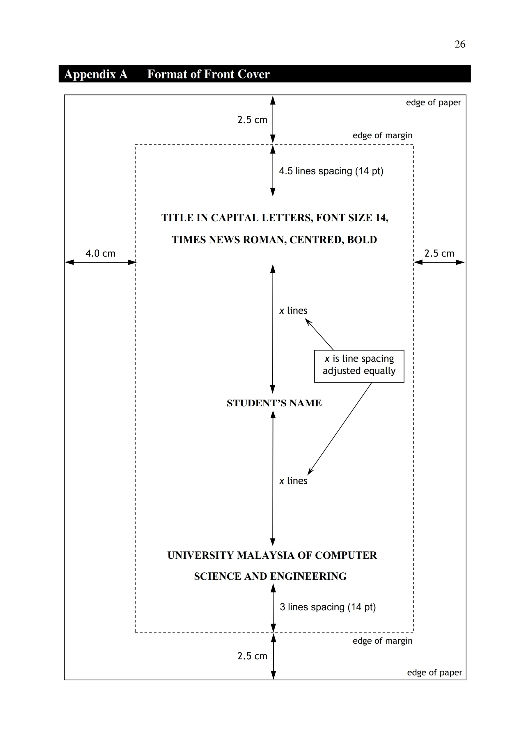

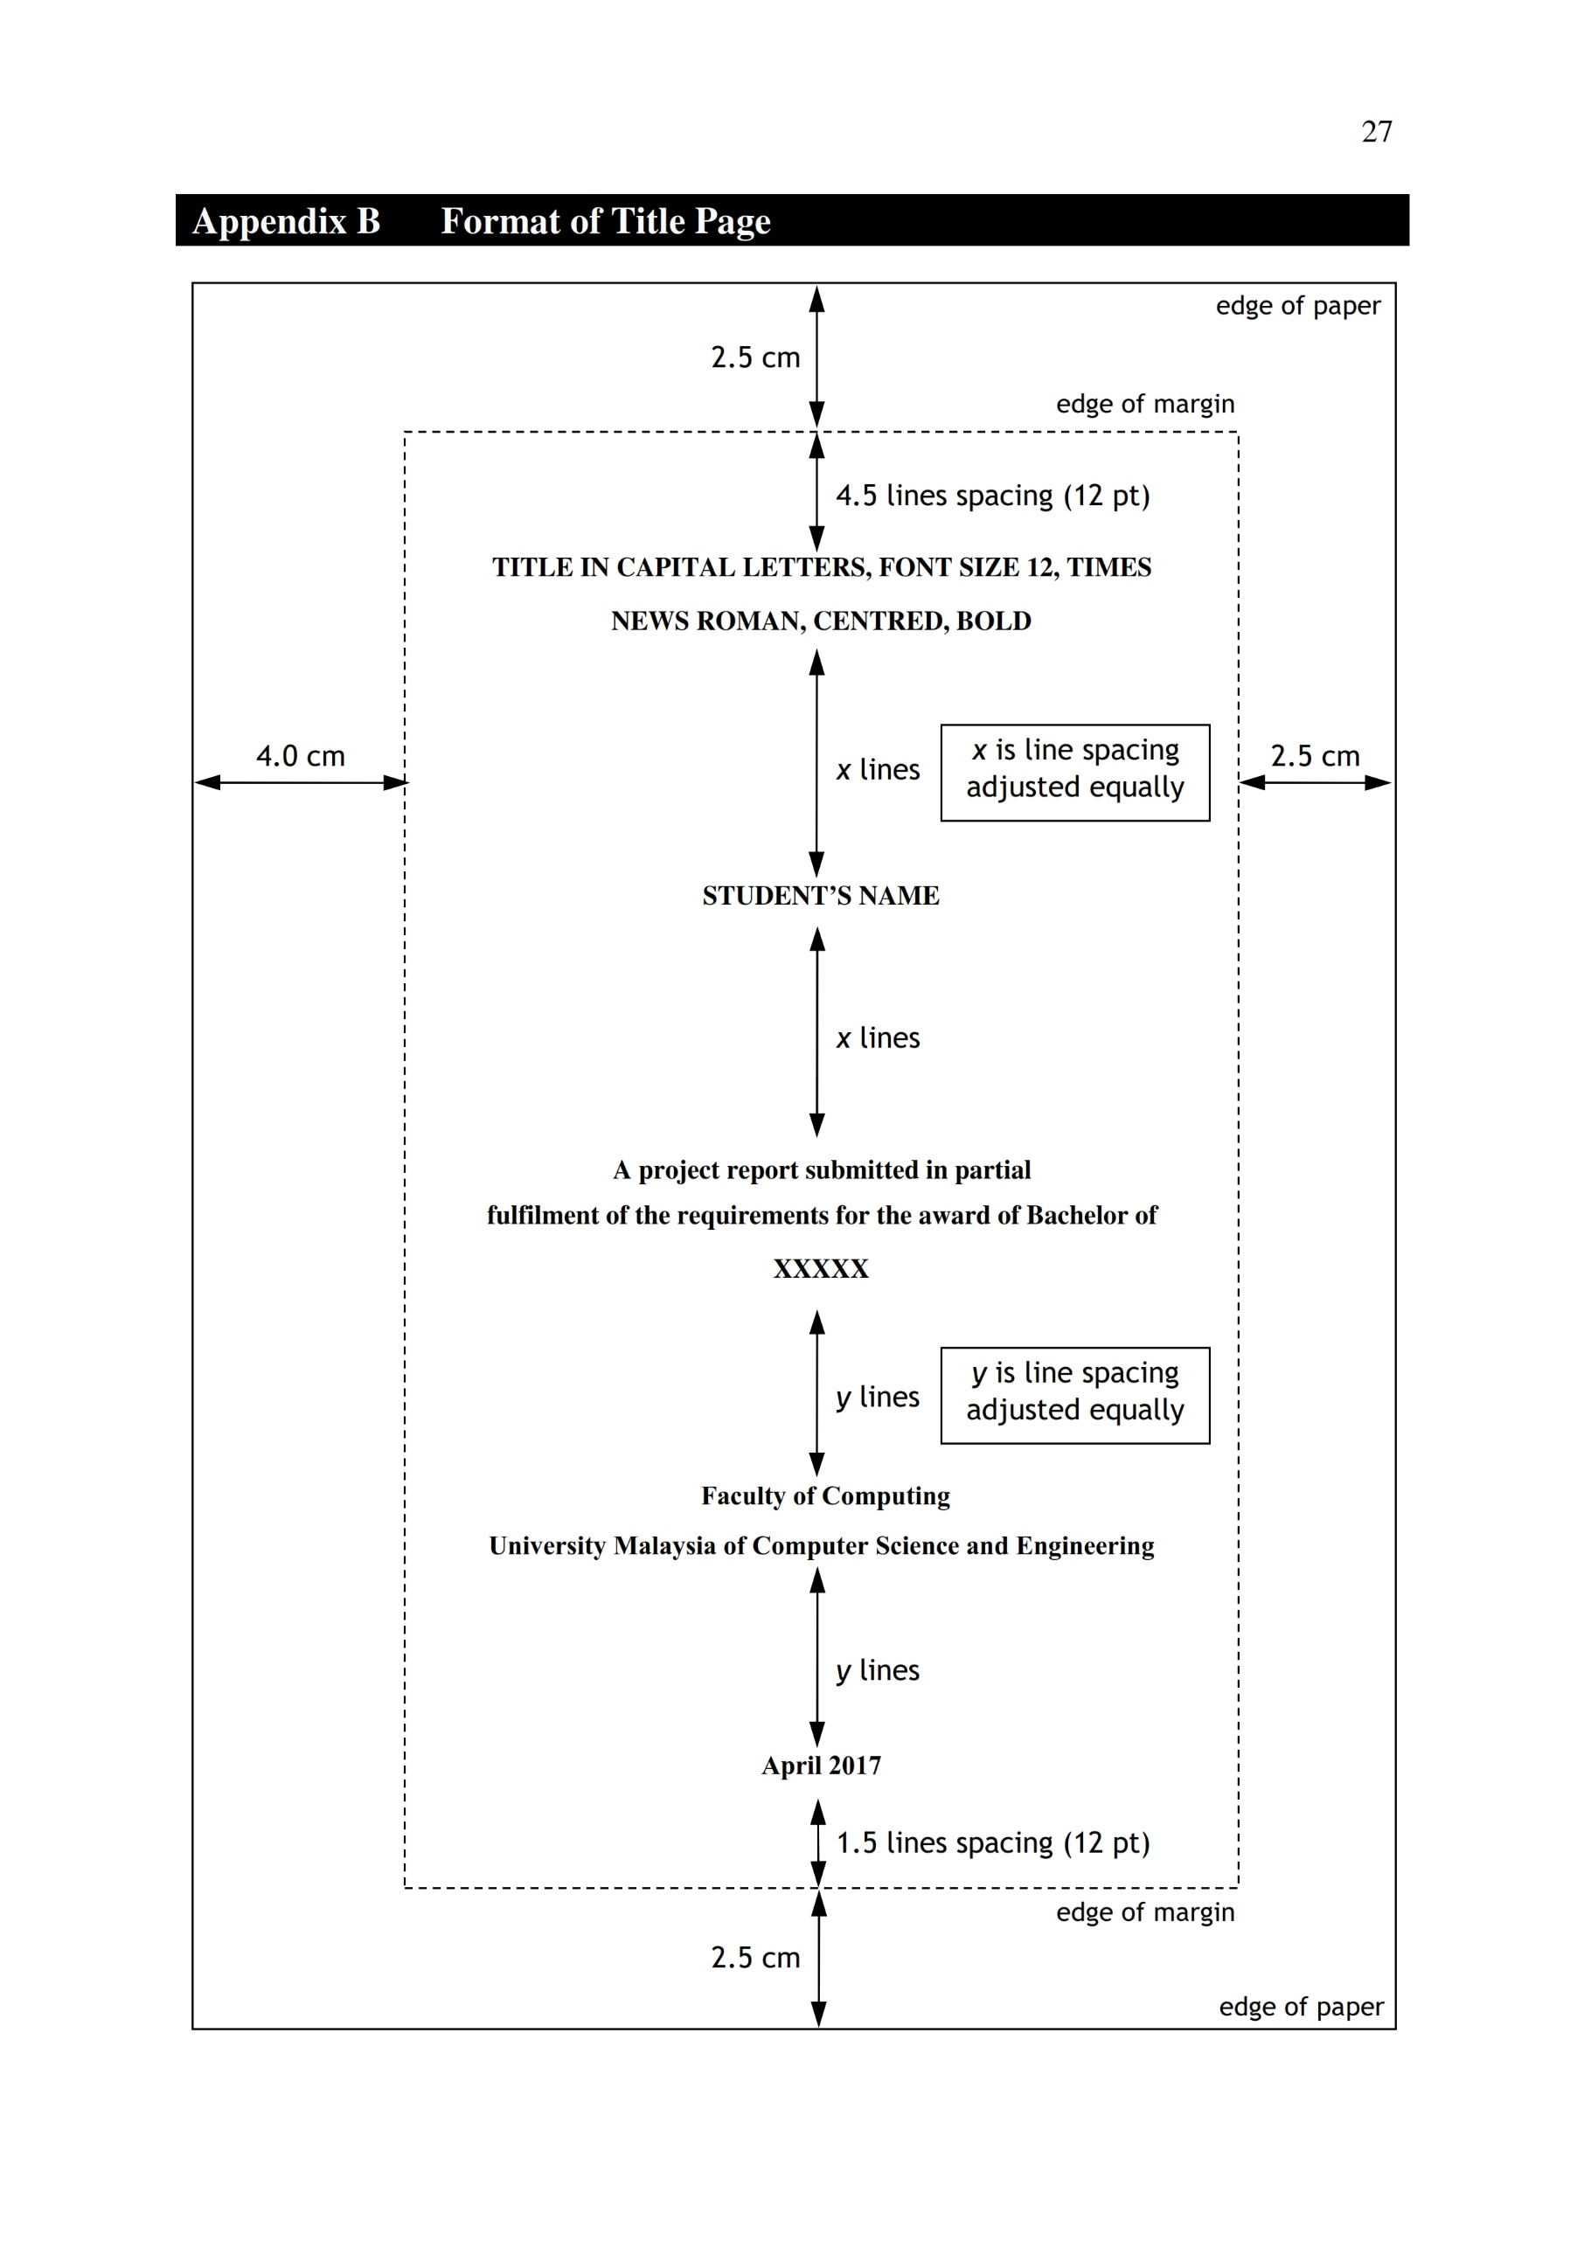

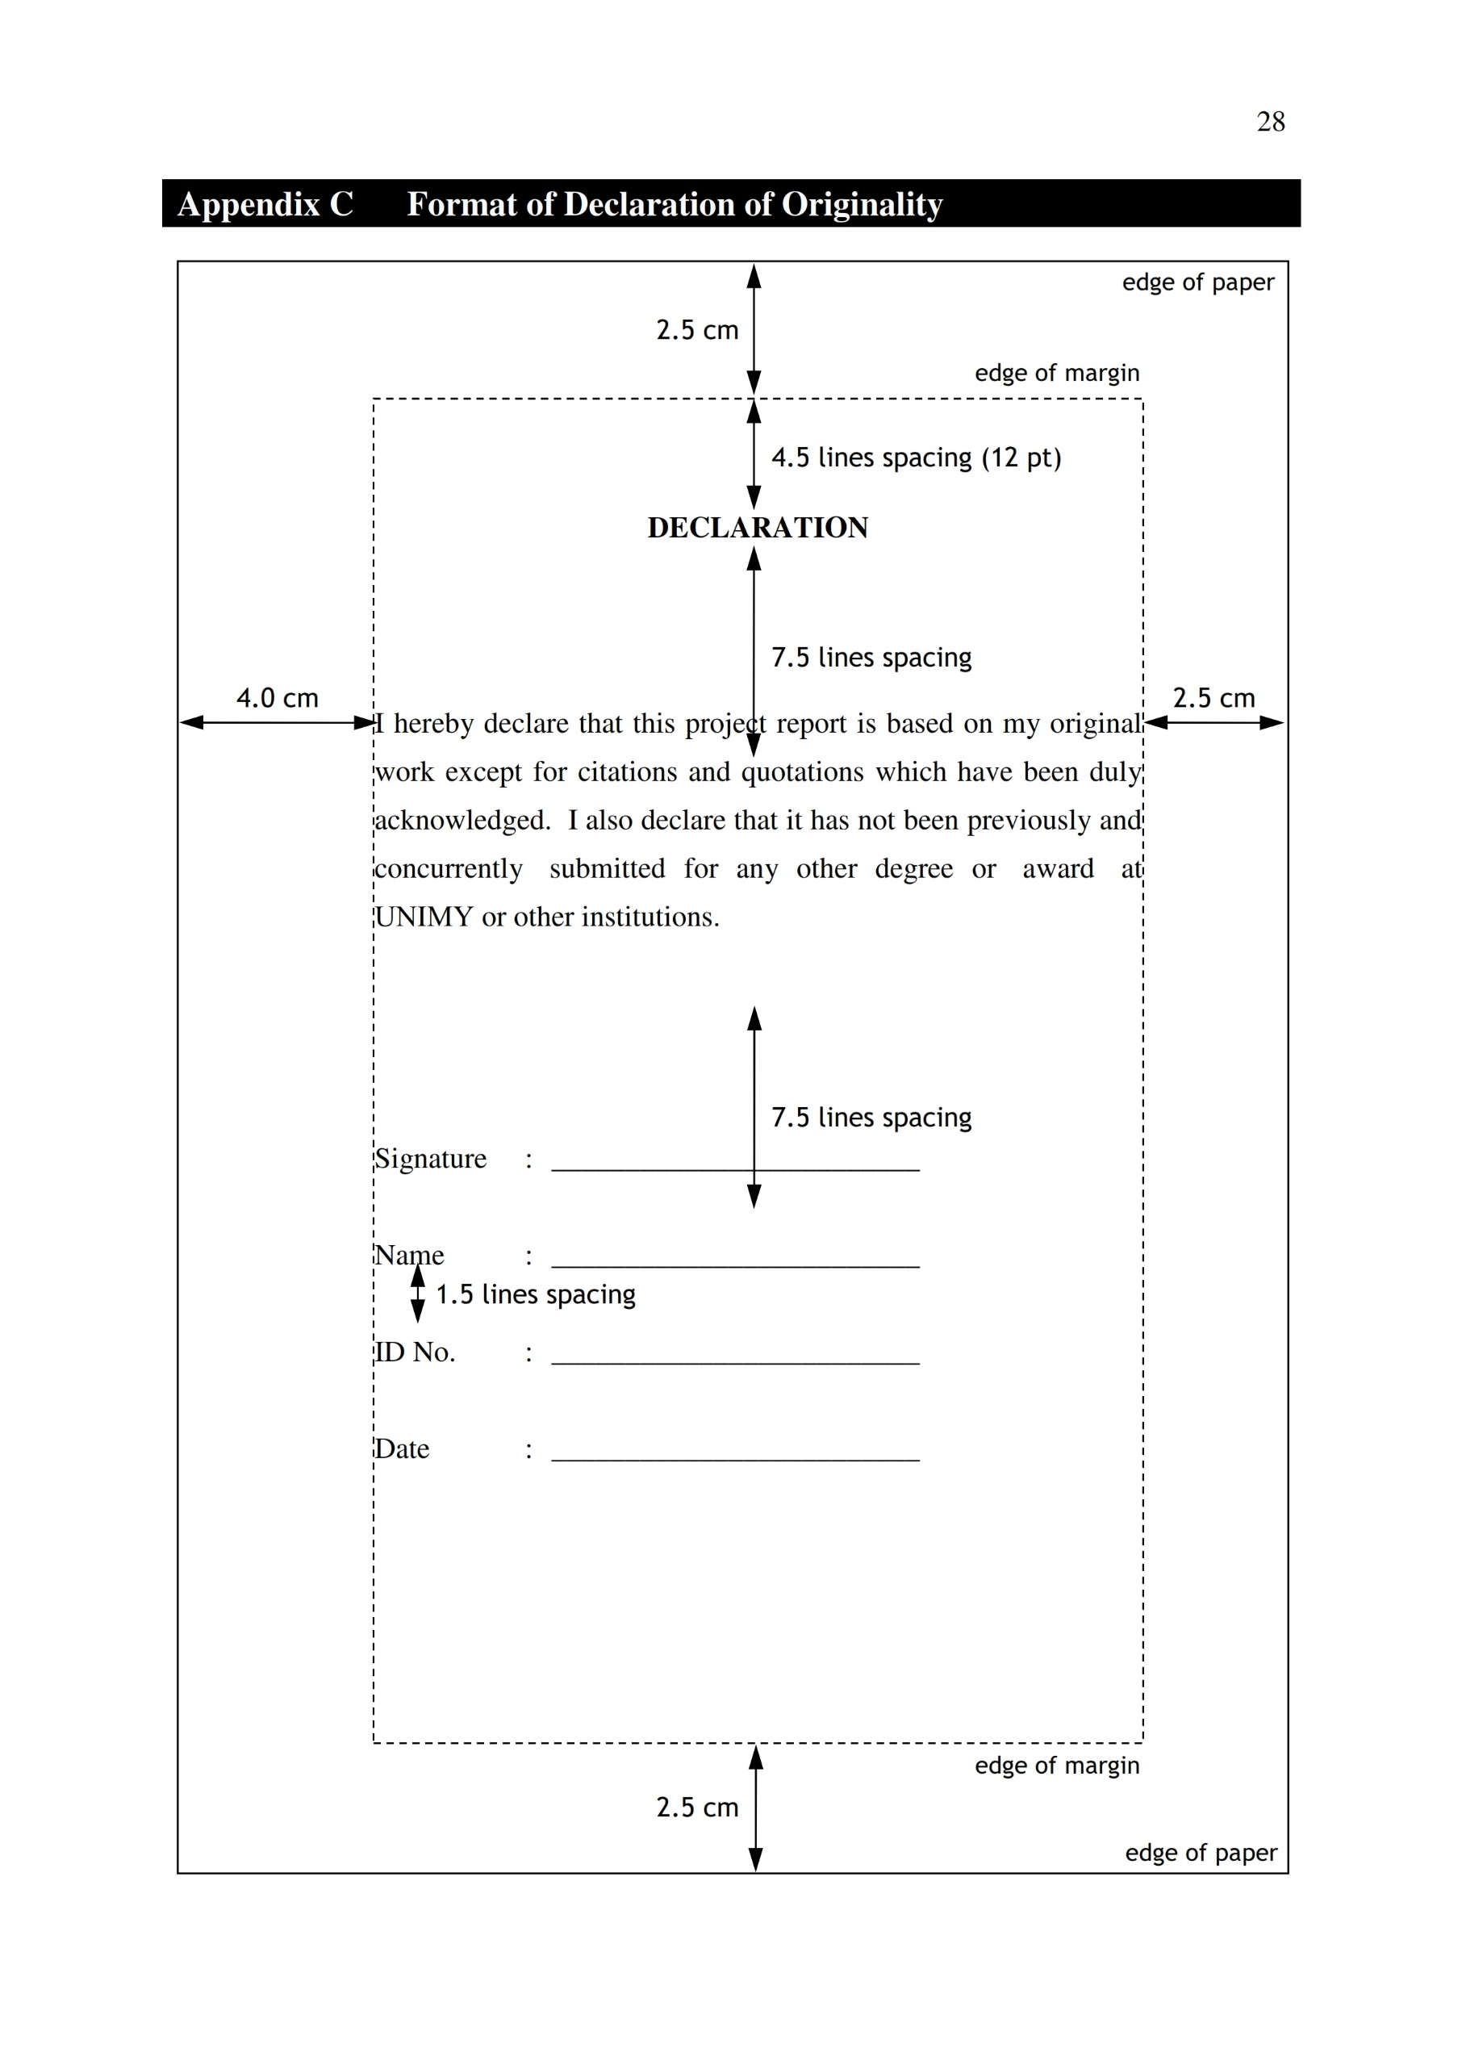

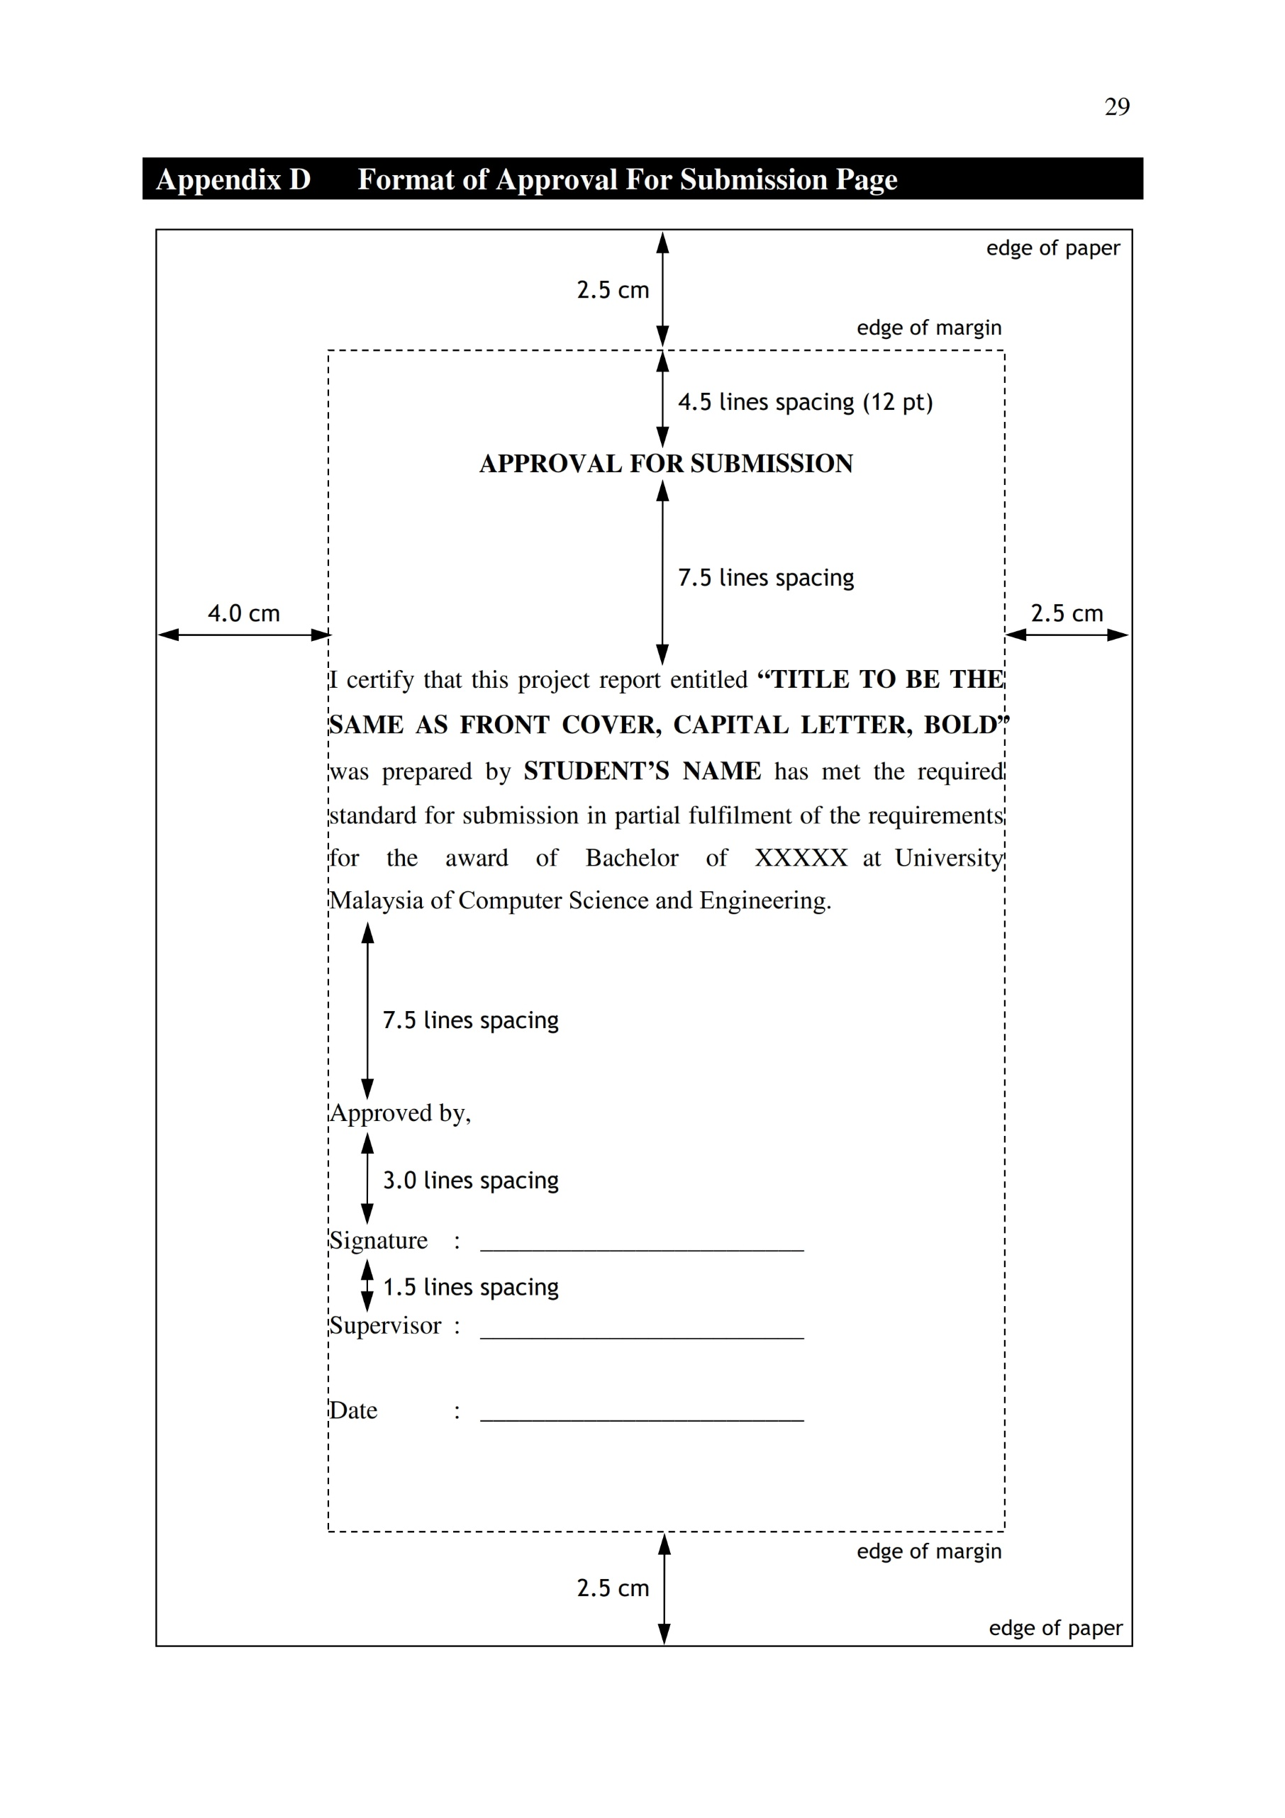

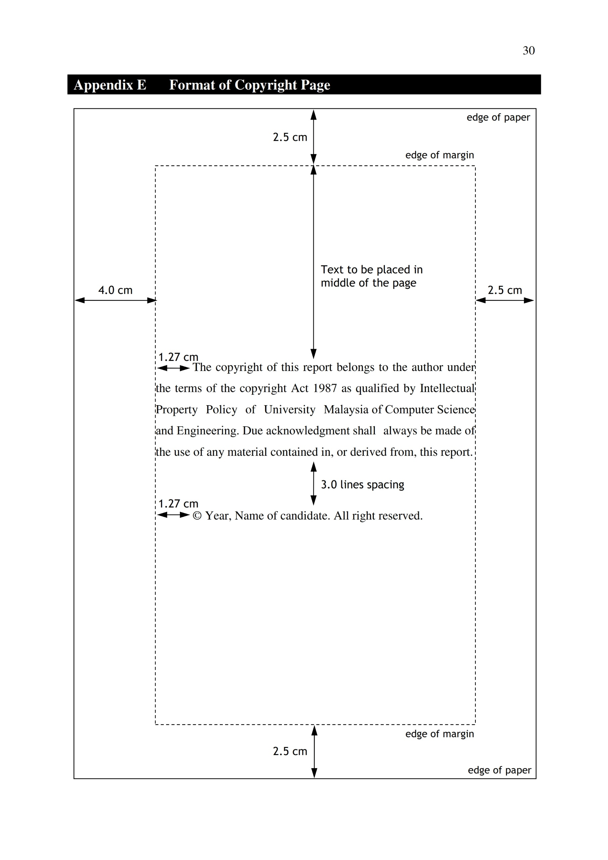

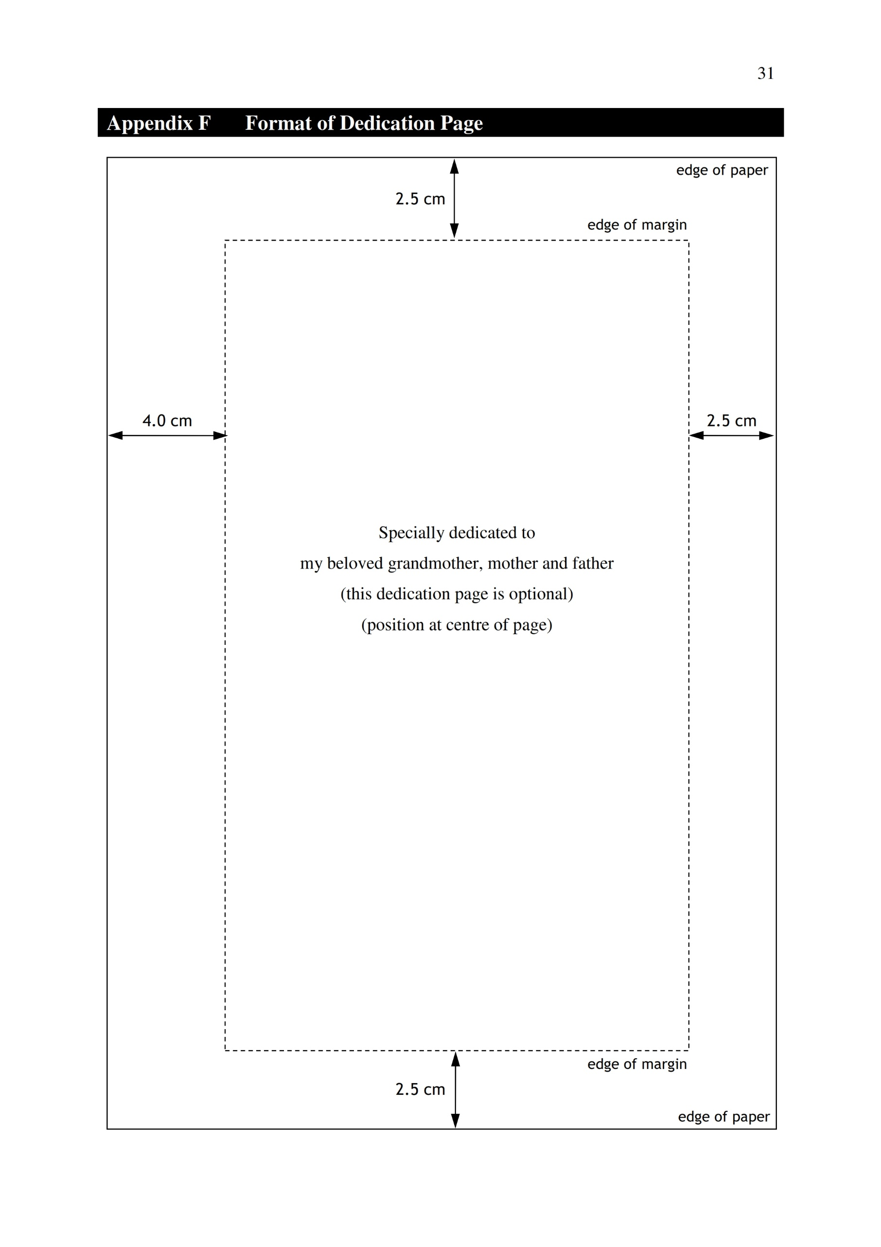

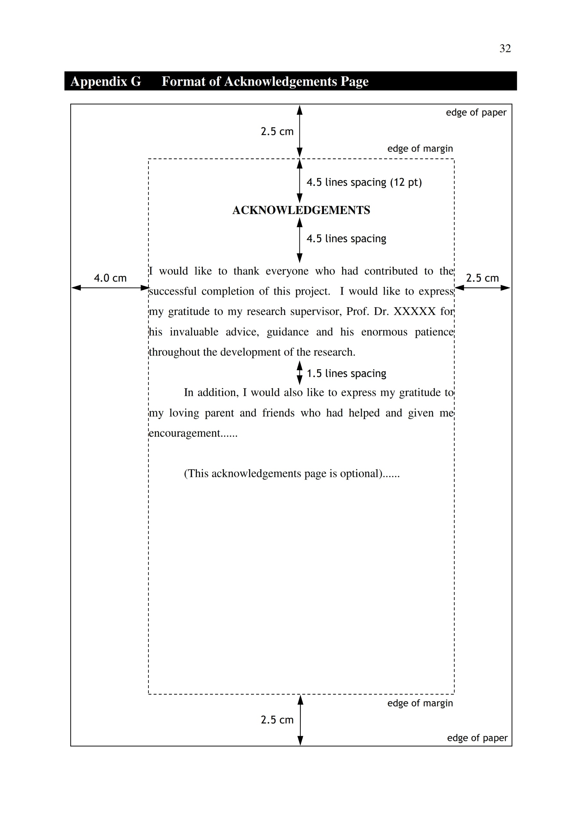

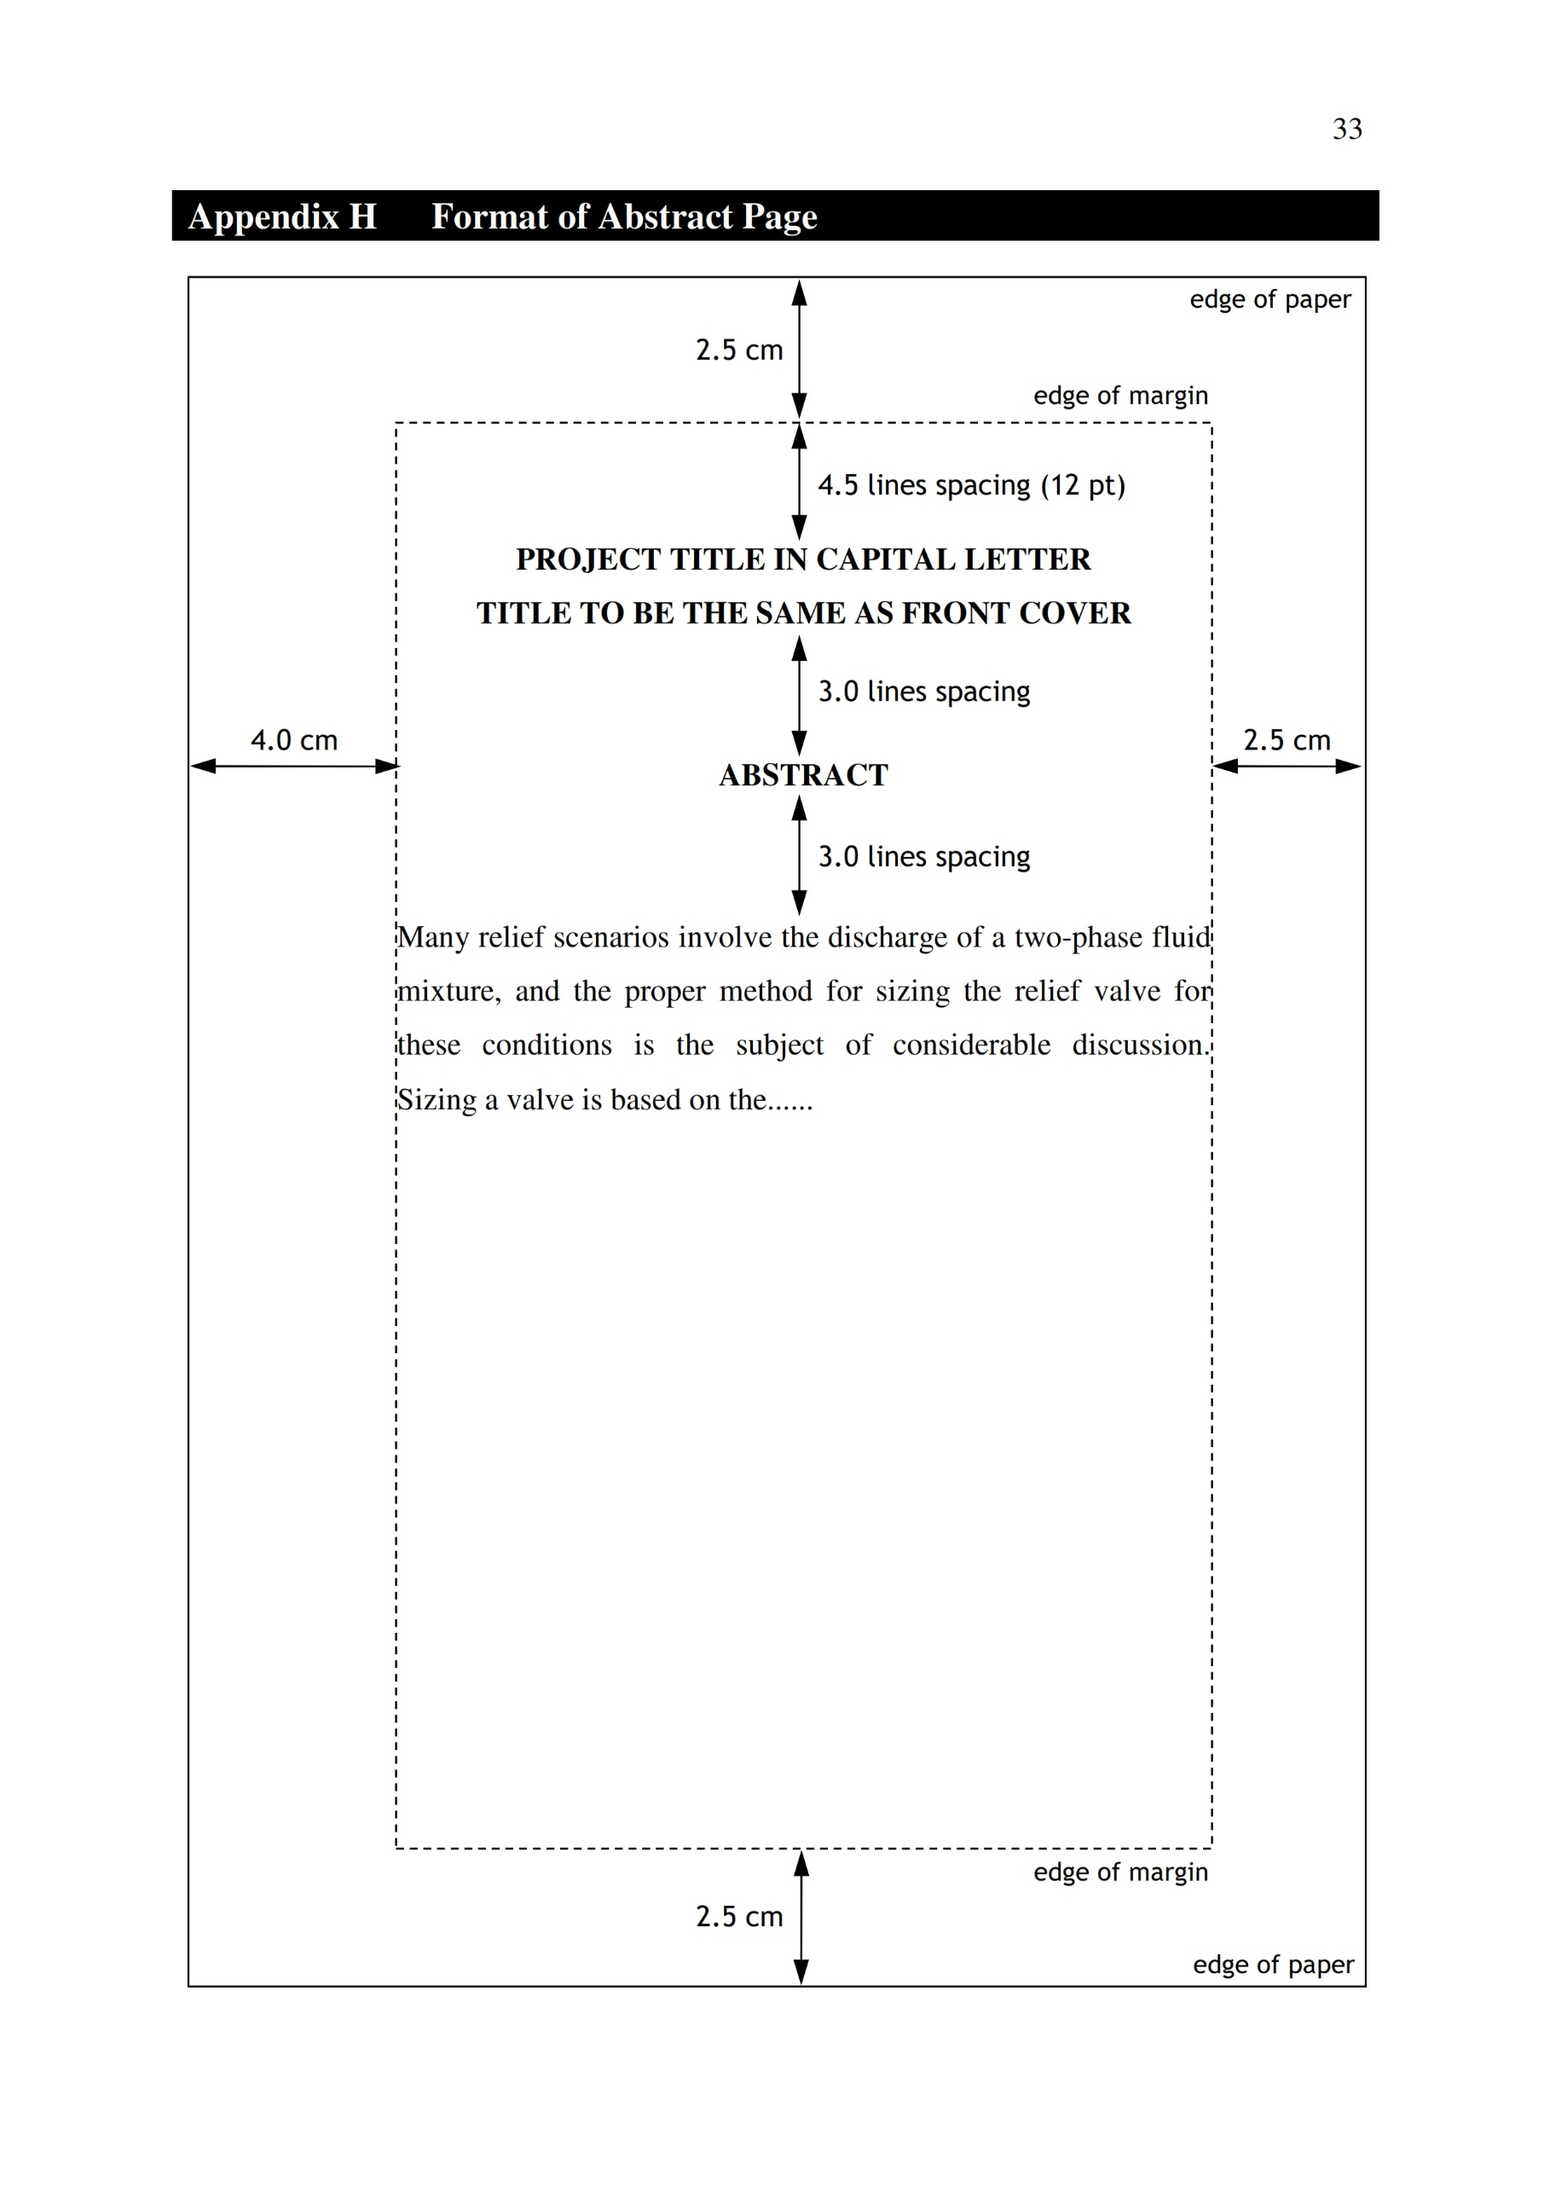

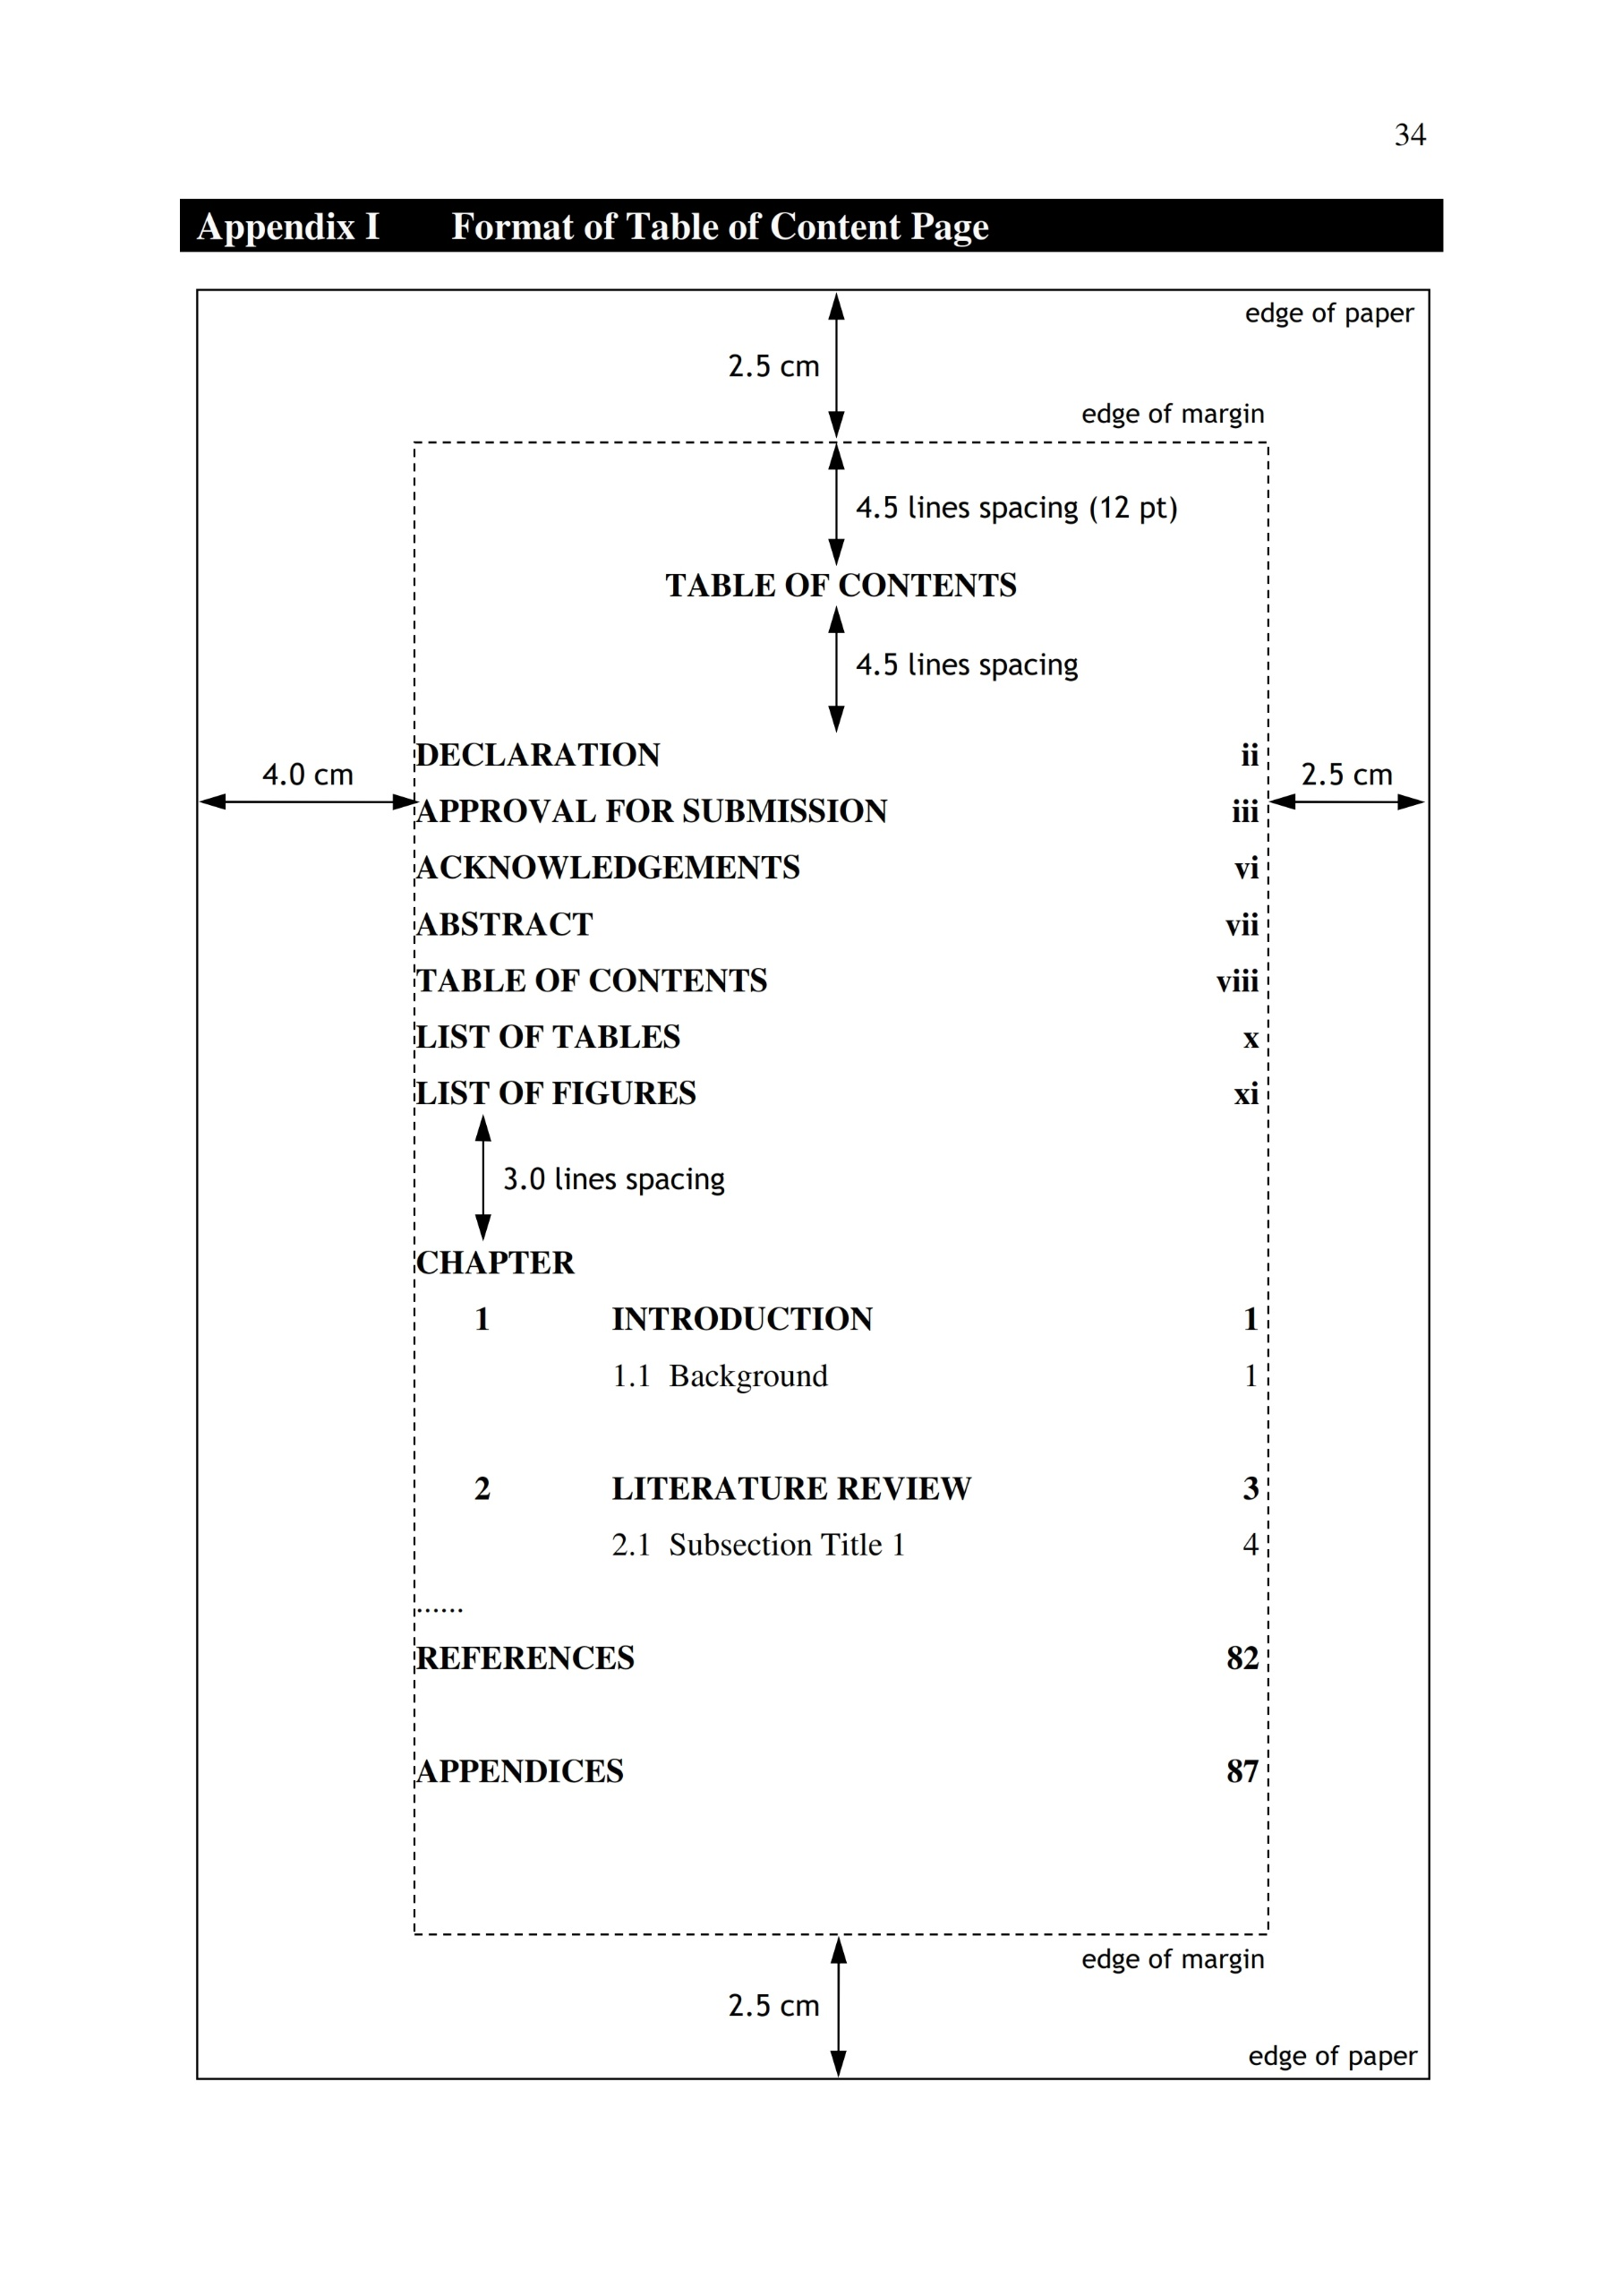

**Appendix I Format of Table of Content Page**

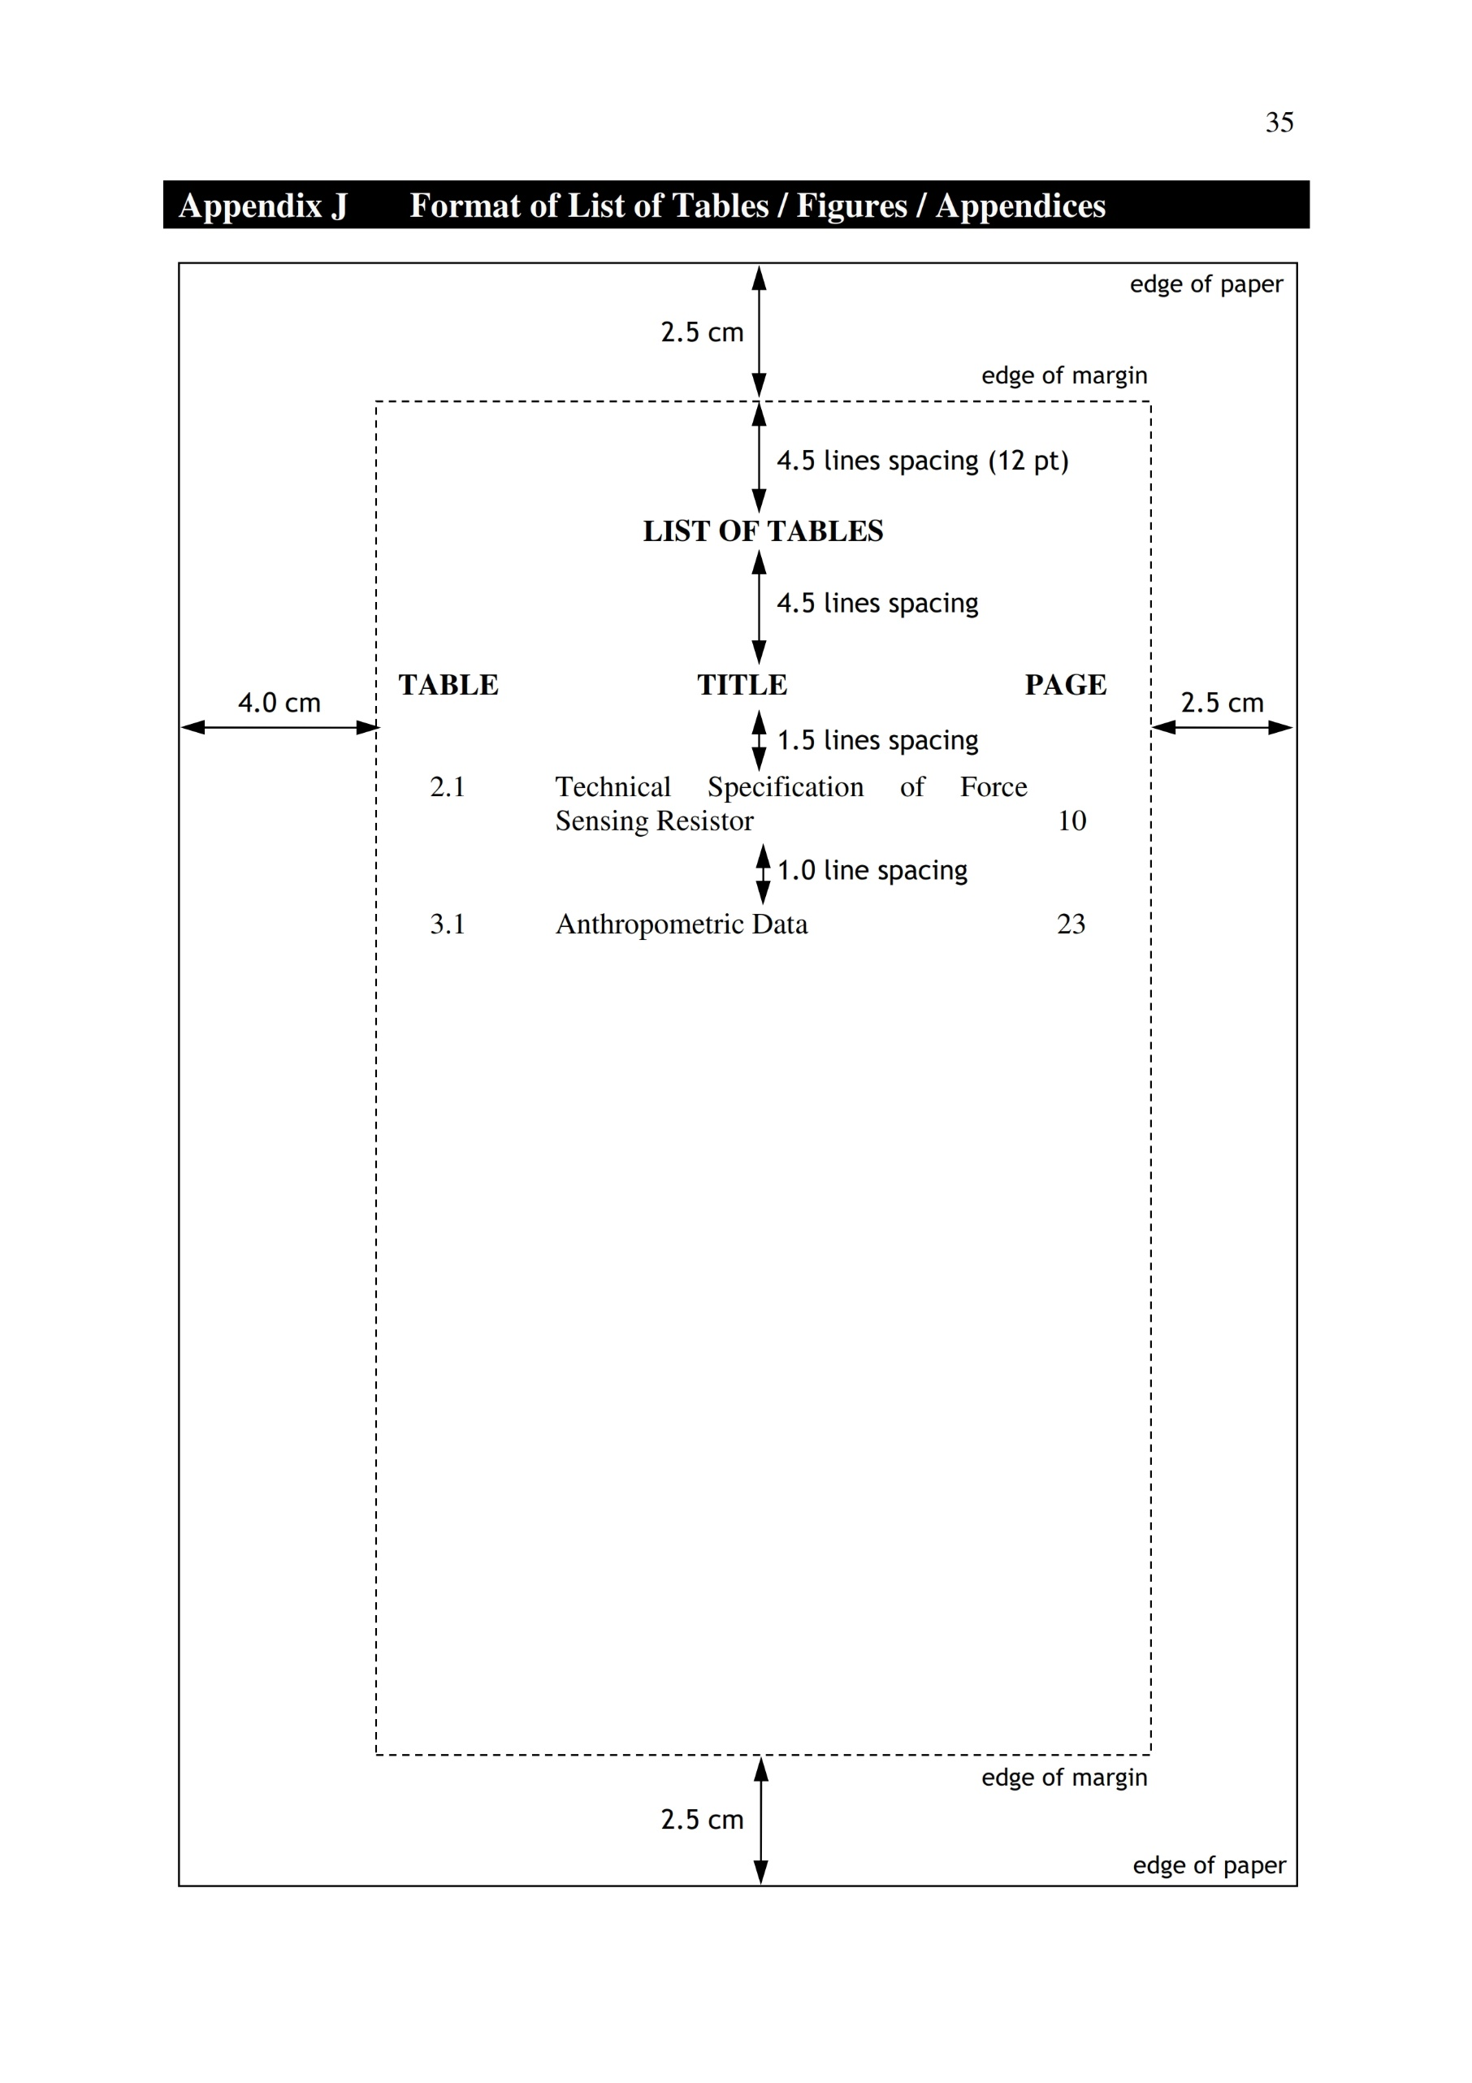

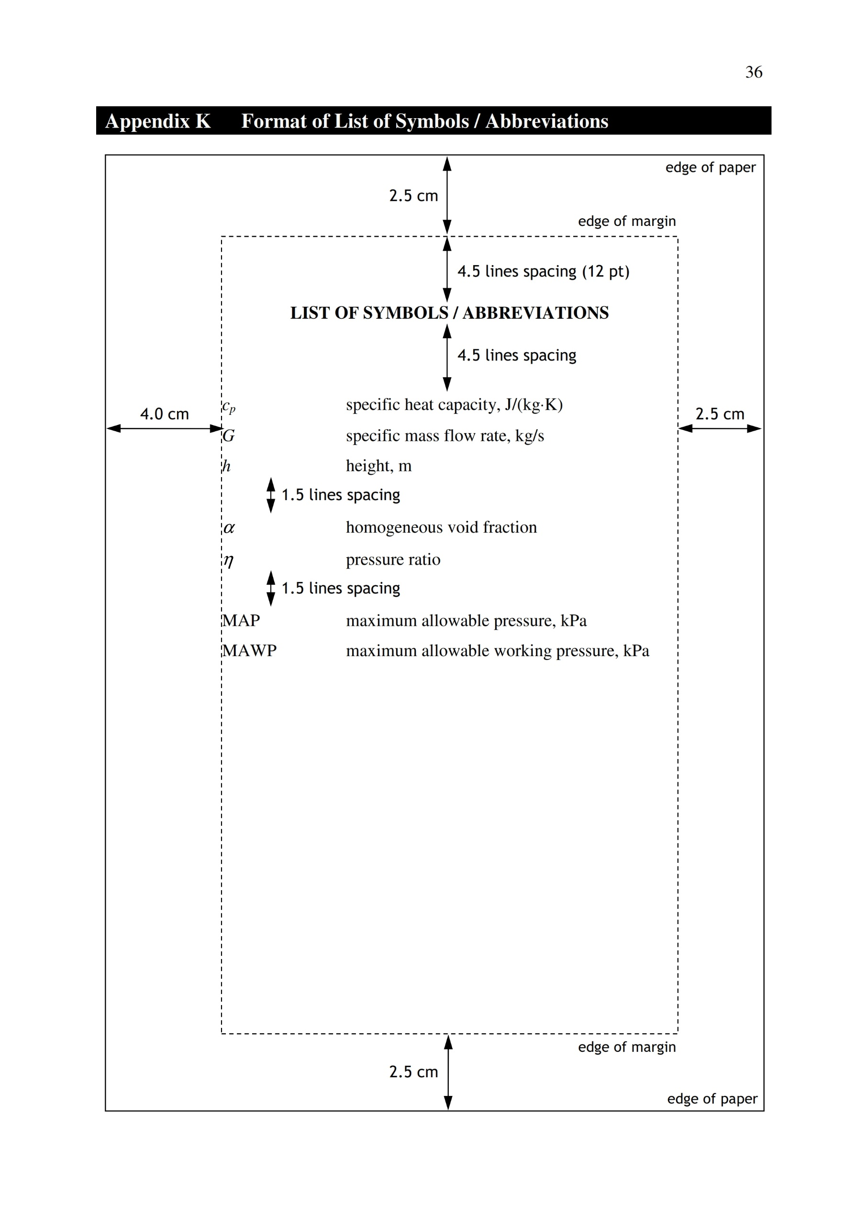

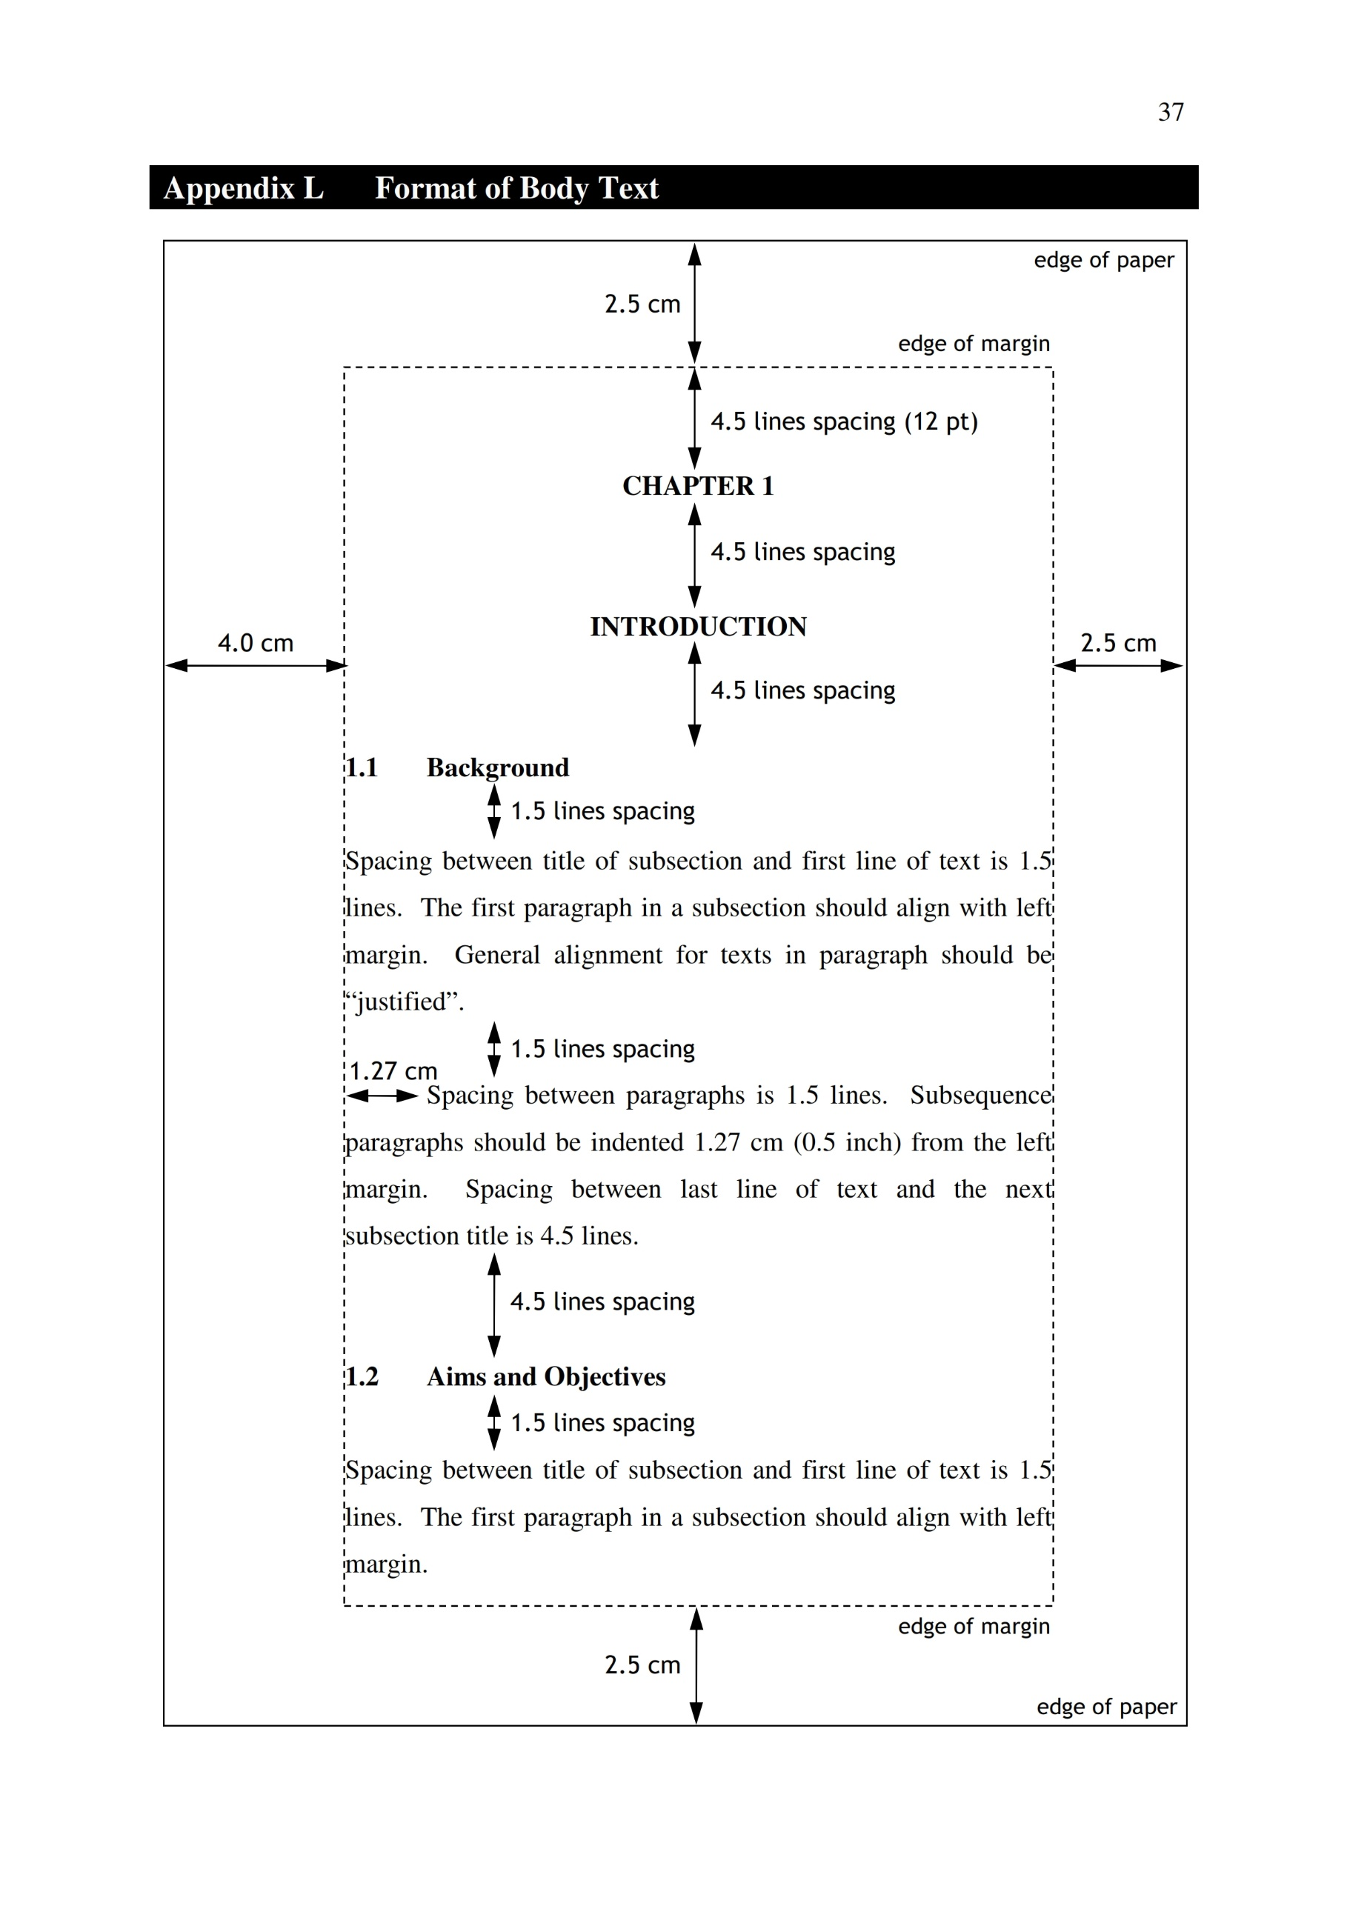

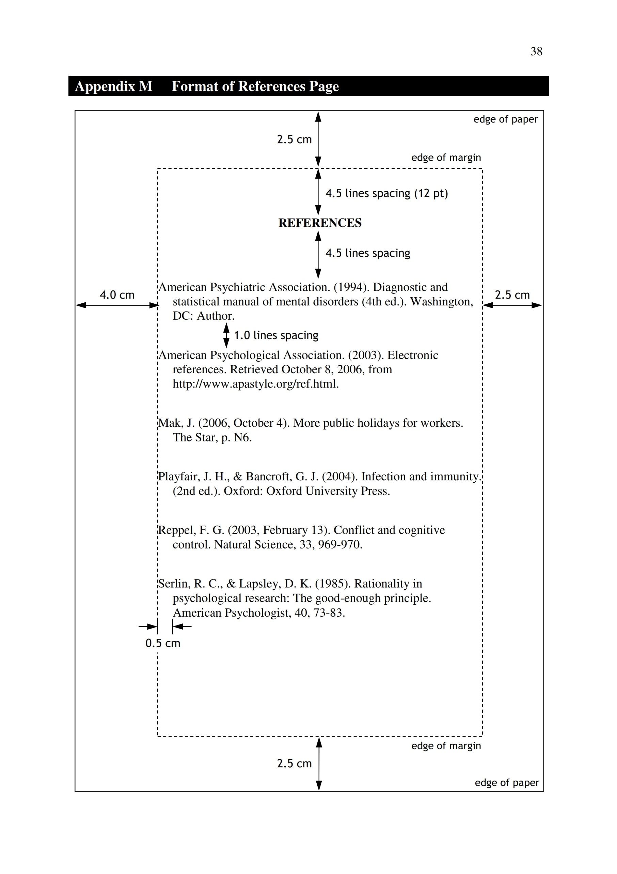

**Appendix N Thesis Spiral Format**

SPIRAL

FRONT

**2019**

**MARY CHEW JIA YI**

**MARY CHEW JIA YI**

**UNIVERSITY MALAYSIA OF COMPUTER SCIENCE AND ENGINEERING**

**ARESUME: A WEB-BASED RESUME GENERATOR WITH AUGMENTED REALITY FEATURES**

**BACHELOR OF SOFTWARE ENGINEERING**